**19/08/2025**

**Module 1**  
what going to learn in this course?

**HTML**  
tags

Structured approach  
well formed web page  
user input  
forms  
media elements  
  
**css**layouts  
grids  
flexboxes  
selectors  
interactivity  
effects  
animations  
keyframes  
testing and debugging  
  
how are HTML CSS used in real world?

HTML:

Hypertext   
this is a link <a> containing links  
markup:

This is heading <h1> containing tags  
DOM:

Model of the objects, update content, setup events, animation HTML elements.  
  
**semantic and meta tags**

Good to semantic write html understand.  
header -   
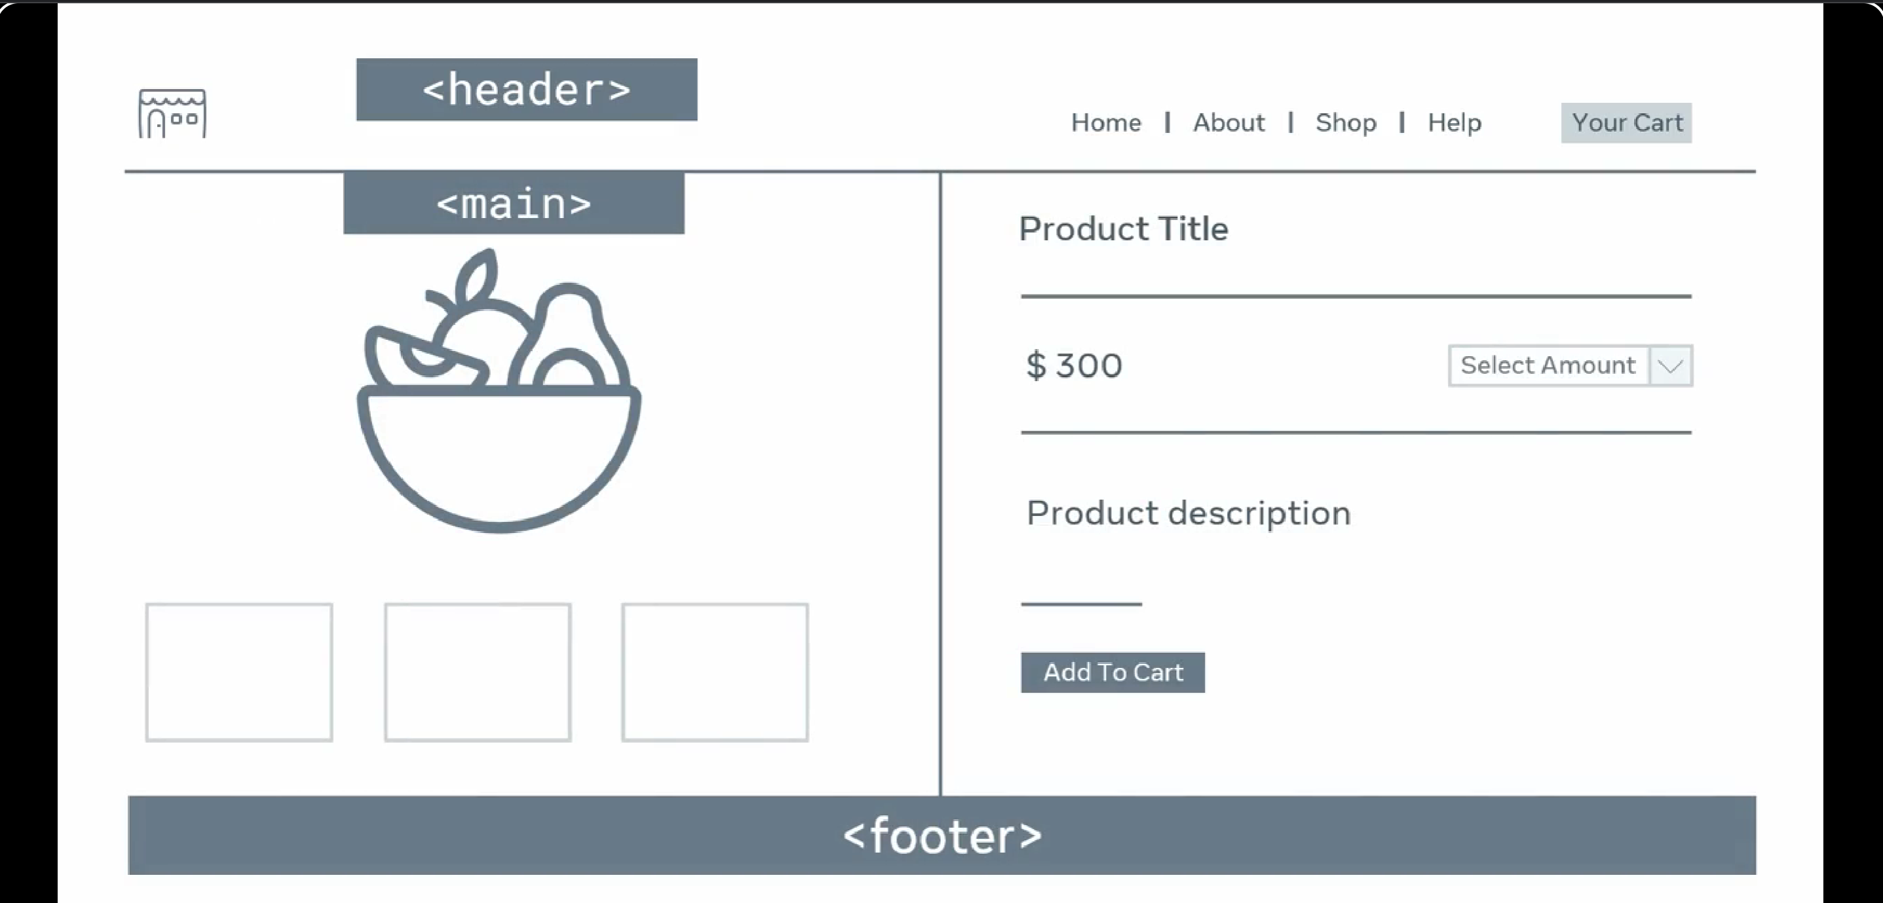  
nav tag placed after head.  
**article**

It indicate self-contained, complete, independently distributable.  
  
forum post , article, blog post, user comment, interactivity widget  
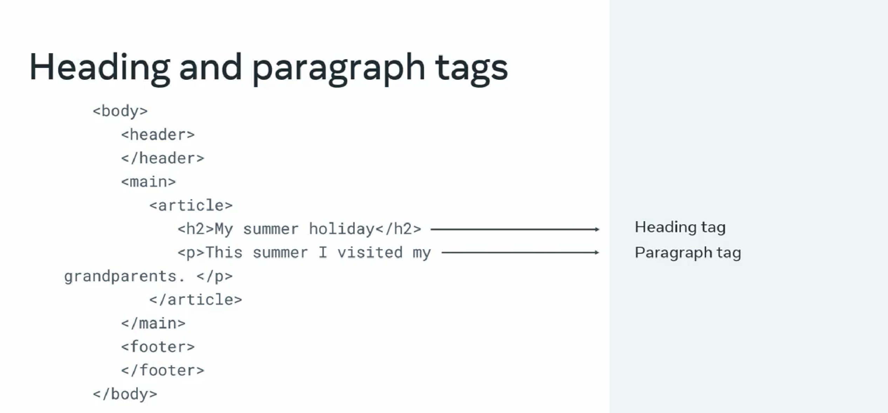

Main content of the page blog post list semantical represent main content of the page.

Footer -> can contain navigation links  
elements can be nested each other if the content is accurately describe content

section element does not required article elements

**nested semantic structure**

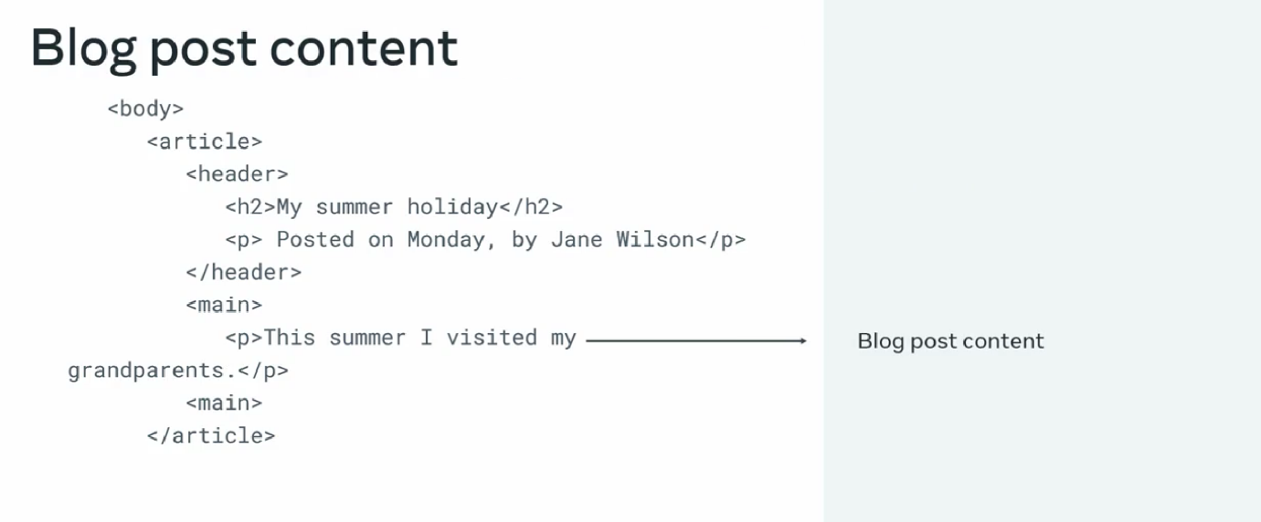

**Section should contain heading element also possible to use section elements to describe your web page. Section does not require article element**

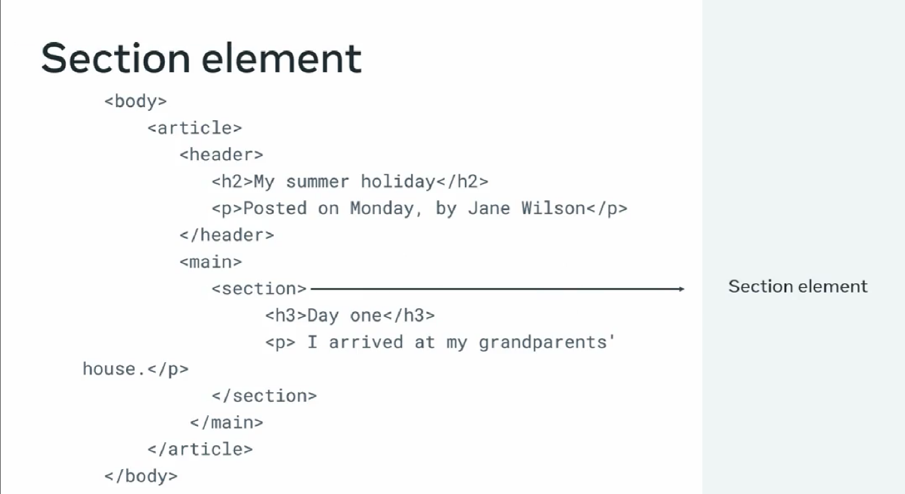

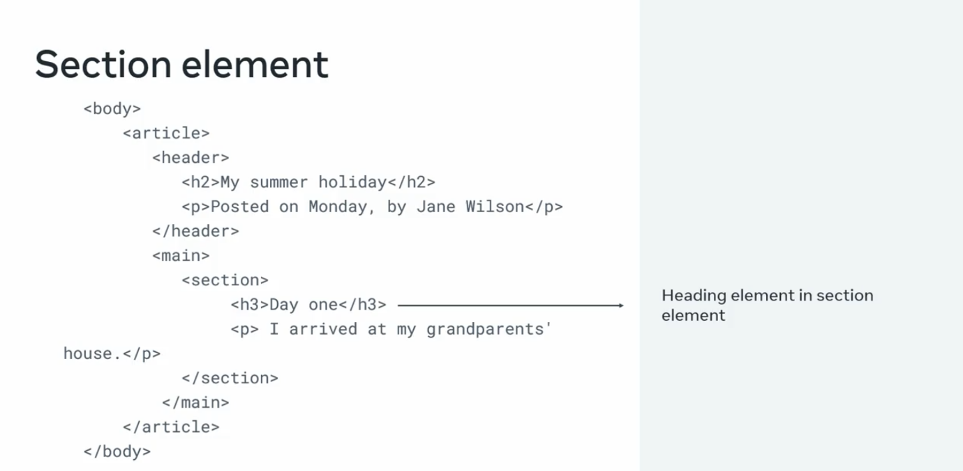

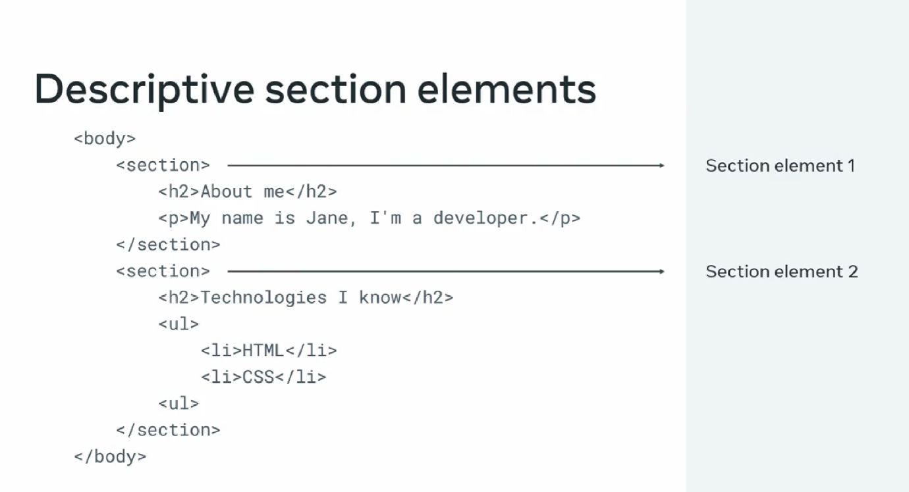

**And now how to semantically describe the contents of the webpage , is more accessible because the content is semantically describe the meaning.  
  
Now, search engines and accessibility software can easily understand the contents of your well formed web page.  
  
  
  
20/08/2025**

Semantic HTML cheat sheet

There are hundreds of semantic tags available to help describe the meaning of your HTML documents. Below is a cheat sheet with some of the most common ones you’ll use in this course and in your development career.

Sectioning tags

Use the following tags to organize your HTML document into structured sections.

<header>

The header of a content section or the web page. The web page header often contains the website branding or logo.

<nav>

The navigation links of a section or the web page.

<footer>

The footer of a content section or the web page. On a web page, it often contains secondary links, the copyright notice, privacy policy and cookie policy links.

<main>

Specifies the main content of a section or the web page.

<aside>

A secondary set of content that is not required to understand the main content.

<article>

An independent, self-contained block of content such as a blog post or product.

<section>

A standalone section of the document that is often used within the body and article elements.

<details>

A collapsed section of content that can be expanded if the user wishes to view it.

<summary>

Specifies the summary or caption of a <details> element.

<h1><h2><h3><h4><h5><h6>

Headings on the web page. <h1> indicates the most important heading whereas <h6> indicates the least important.

Content tags

<blockquote>

Used to describe a quotation.

<dd>

Used to define a description for the preceding <dt> element.

<dl>

Used to define a description list.

<dt>

Used to describe terms inside <dl> elements.

<figcaption>

Defines a caption for a photo image.

<figure>

Applies markup to a photo image.

<hr>

Adds a horizontal line to the parent element.

<li>

Used to define an item within a list.

<menu>

A semantic alternative to <ul> tag.

<ol>

Defines an ordered list.

<p>

Defines a paragraph.

<pre>

Used to represent preformatted text. Typically rendered in the web browser using a monospace font.

<ul>

Unordered list

Inline tags

<a>

An anchor link to another HTML document.

<abbr>

Specifies that the containing text is an abbreviation or acronym.

<b>

Bolds the containing text. When used to indicate importance use <strong> instead.

<br>

A line break. Moves the subsequent text to a new line.

<cite>

Defines the title of creative work (for example a book, poem, song, movie, painting or sculpture). The text in the <cite> element is usually rendered in italics.

<code>

Indicates that the containing text is a block of computer code.

<data>

Indicates machine-readable data.

<em>

Emphasizes the containing text.

<i>

The containing text is displayed in italics. Used to indicate idiomatic text or technical terms.

<mark>

The containing text should be marked or highlighted.

<q>

The containing text is a short quotation.

<s>

Displays the containing text with a strikethrough or line through it.

<samp>

The containing text represents a sample.

<small>

Used to represent small text, such as copyright and legal text.

<span>

A generic element for grouping content for CSS styling.

<strong>

Displays the containing text in bold. Used to indicate importance.

<sub>

The containing text is subscript text, displayed with a lowered baseline.

<sup>

The containing text is superscript text, displayed with a raised baseline.

<time>

A semantic tag used to display both dates and times.

<u>

Displays the containing text with a solid underline.

<var>

The containing text is a variable in a mathematical expression.

Embedded content and media tags

<audio>

Used to embed audio in web pages.

<canvas>

Used to render 2D and 3D graphics on web pages.

<embed>

Used as a containing element for external content provided by an external application such as a media player or plug-in application.

<iframe>

Used to embed a nested web page.

<img>

Embeds an image on a web page.

<object>

Similar to <embed> but the content is provided by a web browser plug-in.

<picture>

An element that contains one <img> element and one or more <source> elements to offer alternative images for different displays/devices.

<video>

Embeds a video on a web page.

<source>

Specifies media resources for <picture>, <audio> and<video> elements.

<svg>

Used to define Scalable Vector Graphics within a web page.

Table tags

<table>

Defines a table element to display table data within a web page.

<thead>

Represents the header content of a table. Typically contains one <tr> element.

<tbody>

Represents the main content of a table. Contains one or more <tr>elements.

<tfoot>

Represents the footer content of a table. Typically contains one <tr> element.

<tr>

Represents a row in a table. Contains one or more <td> elements when used within <tbody> or <tfoot>. When used within <thead>, contains one or more <th> elements.

<td>

Represents a cell in a table. Contains the text content of the cell.

<th>

Defines a header cell of a table. Contains the text content of the header.

<caption>

Defines the caption of a table element.

<colgroup>

Defines a semantic group of one or more columns in a table for formatting.

<col>

Defines a semantic column in a table.  
  
**semantic tags in action  
  
basic structure:**

1.header element

2.nav element

3.main element

4.footer element  
sematic tags help the search engine and software to understand the code different section of the document  
Little Lemon Restaurant will get lots of business through their

blog, and

their customers with disabilities will be able to access the blog with no problems

**metadata**

**SEO**search engine optimization  
make improve:

Content, semantics, delivery  
**it will analysis the HTML document and media content  
if link found it will continue to the link until last link.**based on the search engine will give result to the web page  
 **meta tags (un seen)**define metadata about web page  
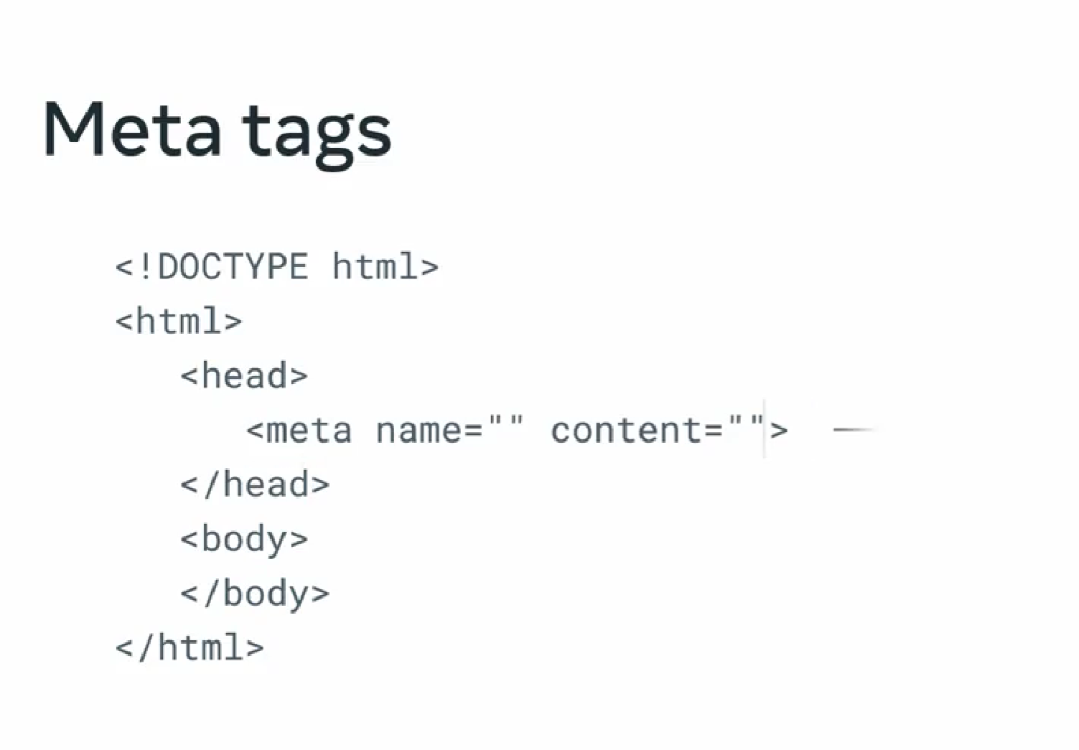  
name = **author** content = Santhosh owner of the company  
name = **description** content=Santhosh first webpage  
name = **keywords** content = holidays, free, summer  
**previously used to manipulated search ranking**.  
  
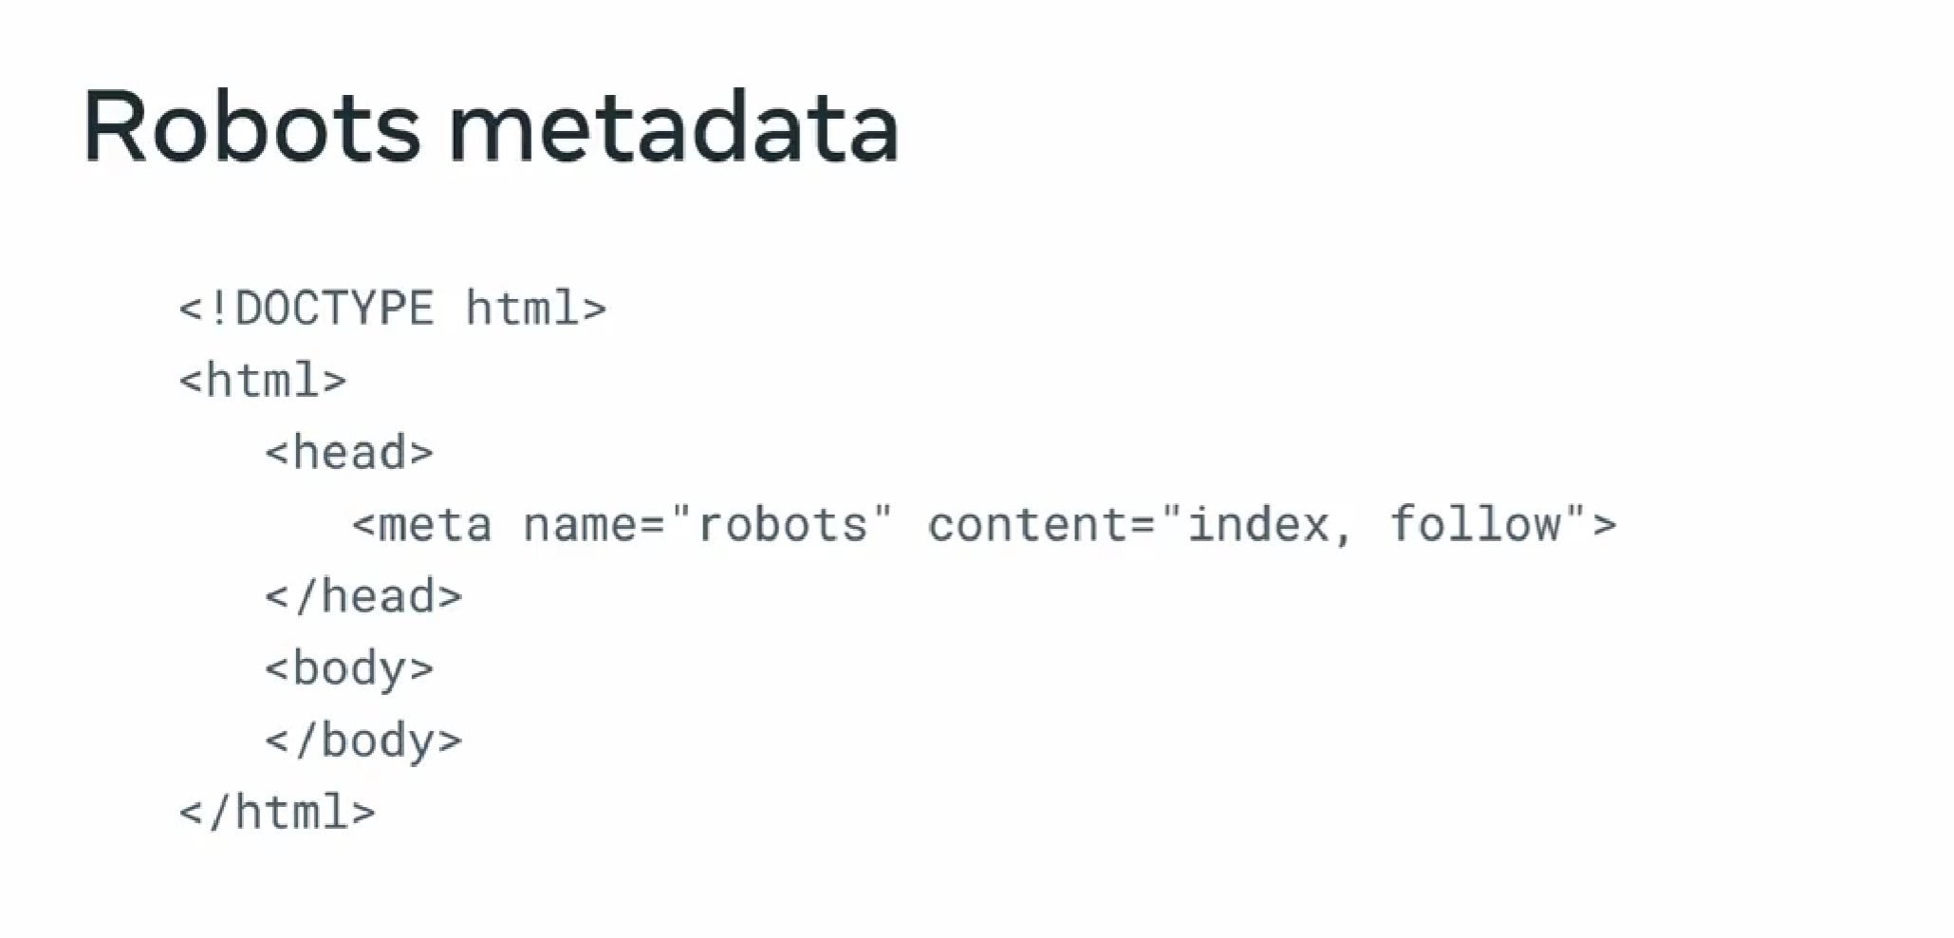

Robots – automated software search engine used to analysis **meta data  
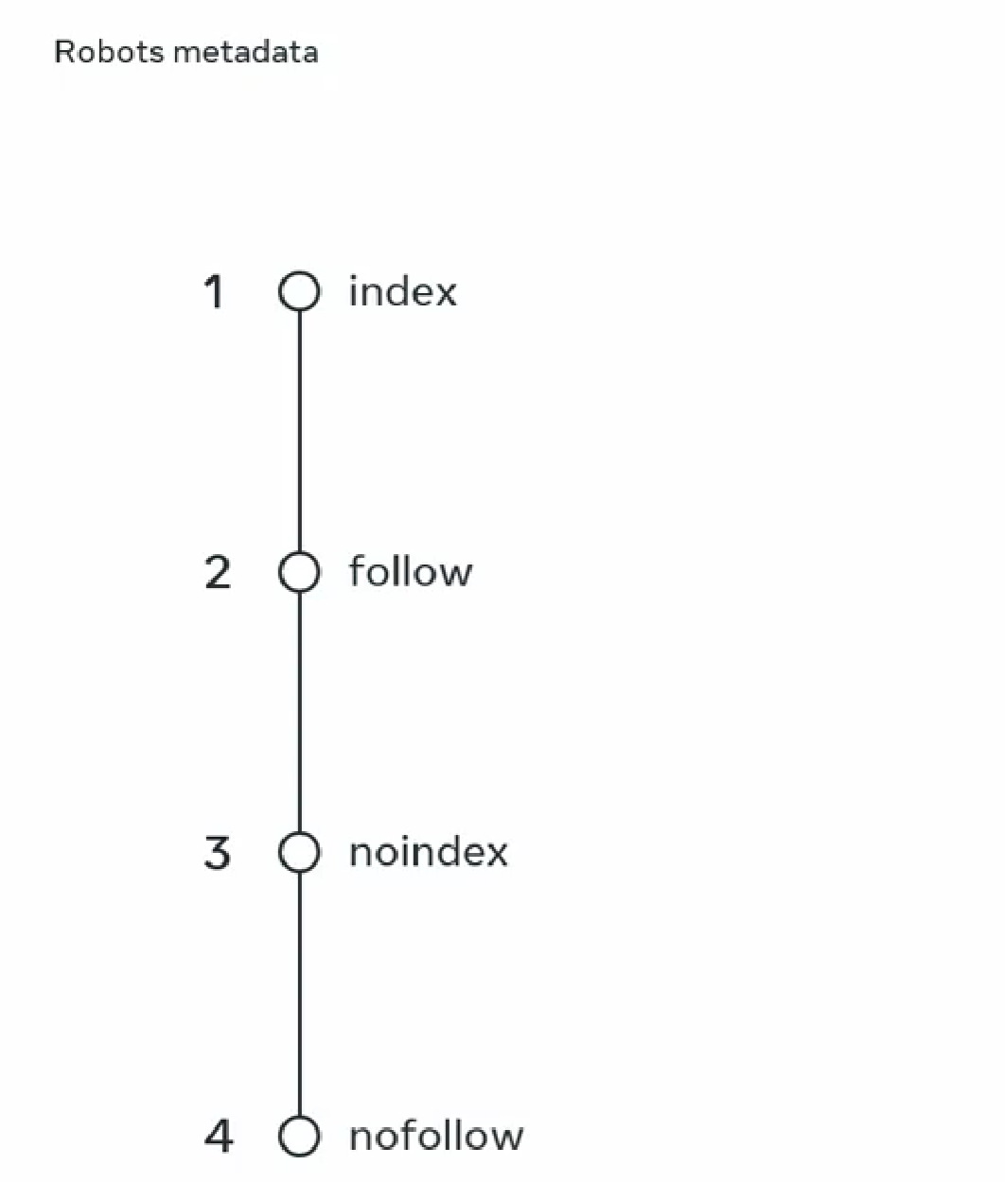**

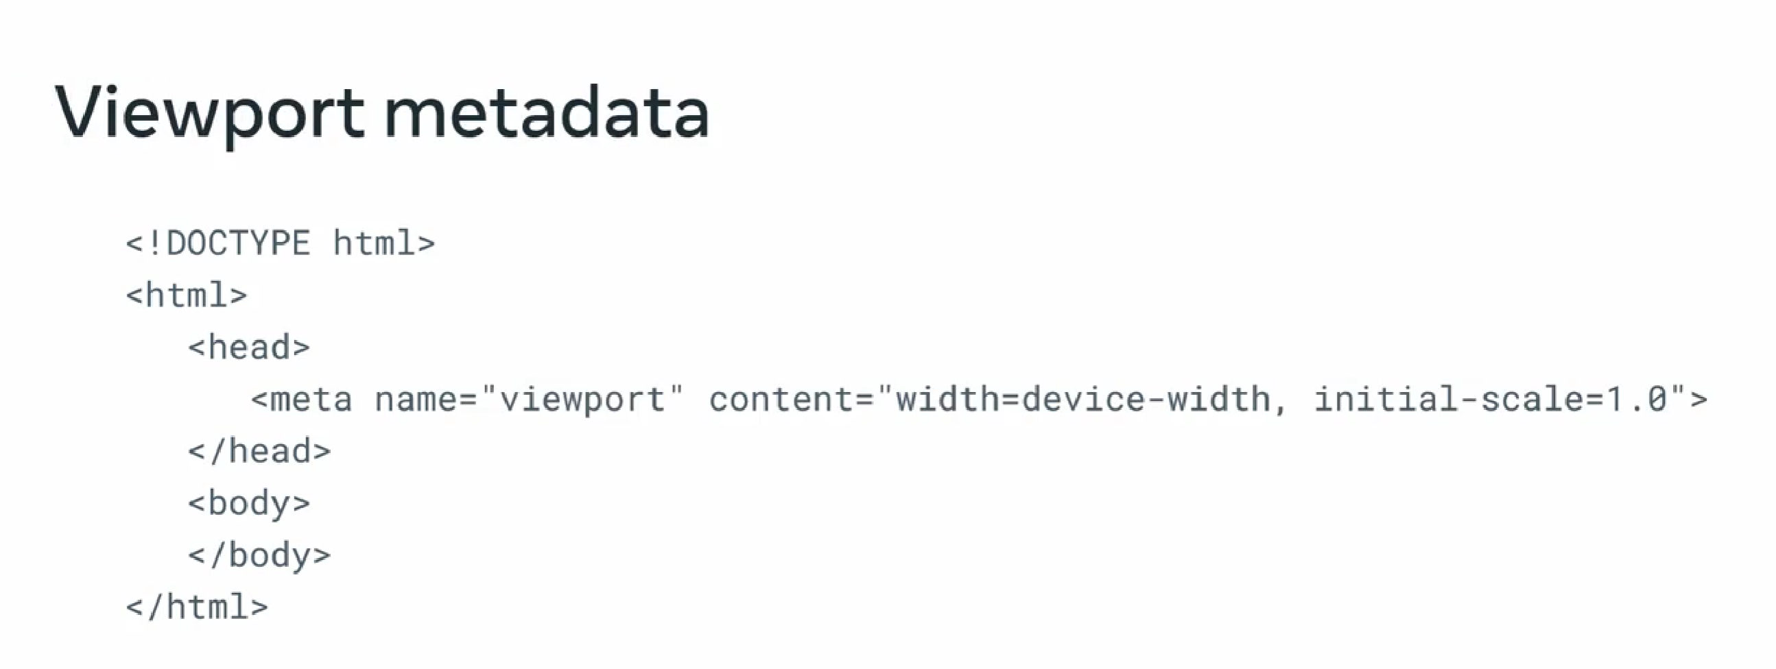

**Its important when creating important webpages.**

**When a page is view in mobile it lead to poor browser experience with out define it.  
user experience, SEO.  
mobile experience part of ranking algorithm**

Data about data  
  
Metadata cheat sheet

HTML <meta> tags

Earlier in the course, you learned about meta tags and how you can leverage them to convey information to search engines to better categorize your pages. We recommend that you keep this cheat sheet handy when building your web applications. The structure of a meta tag is as follows.

Name

The name of the property can be anything you like, although browsers usually expect a value they understand and can take an action upon. An example would be <meta name="author" content="name"> to state the author of the page.

Content

The content field specifies the property's value. For example, you can use <meta name="language" content="english">, to specify the language of the webpage to search engines.

Charset

The charset is a special field that lets you specify the character encoding used for the page so that the browser can display it properly. The most frequently used is utf-8, and you would add it to your HTML header as follows: <meta charset="UTF-8">

HTTP-equiv

This field stands for HTTP equivalent, and it’s used to simulate HTTP response headers. This is rare to see, and it’s recommended to use HTTP headers over HTML http-equiv meta tags. For example, the next tag would instruct the browser to refresh the page every 30 minutes: <meta http-equiv="refresh" content="30">

Basic meta tags (meta tags For SEO)

<meta name="description"/> provides a brief description of the web page

<meta name=”title”/> specifies the title of the web page

<meta name="author" content="name"> specifies the author of the web page

<meta name="language" content="english"> specifies the language of the web page

<meta name="robots" content="index,follow" /> tells search engines how to crawl or index a certain page

<meta name="google"/> tells Google not to show the sitelinks search box for your page when showing search results

<meta name="googlebot" content=”notranslate” /> tells Google you don’t want to provide an automatic translation for your page if the user uses a different language

<meta name="revised" content="Sunday, July 18th, 2010, 5:15 pm" /> specifies the last modified date and time on which you have made certain changes

<meta name="rating" content="safe for kids"> specifies the expected audience for your page

<meta name="copyright" content="Copyright 2022"> specifies a Copyright

<meta http-equiv="..."/> tags

<meta http-equiv="content-type" content="text/html"> specifies the format of the document returned by the server

<meta http-equiv="default-style"/> specifies the format of the styling document

<meta http-equiv="refresh"/> specifies the duration of the page before it’s considered stale

<meta http-equiv=”Content-language”/> specifies the language of the page

<meta http-equiv="Cache-Control" content="no-cache"> instructs the browser how to cache your page

Responsive design/mobile meta tags

<meta name="format-detection" content="telephone=yes"/> indicates that telephone numbers should appear as hypertext links that can be clicked to make a phone call

<meta name="HandheldFriendly" content="true"/> specifies that the page can be properly visualized on mobile devices

<meta name="viewport" content="width=device-width, initial-scale=1.0"/> specifies the area of the window in which web content can be seen  
  
  
**21/08/2025  
  
bare bones layouts:**template folder  
index.html  
js folder  
css folder  
  
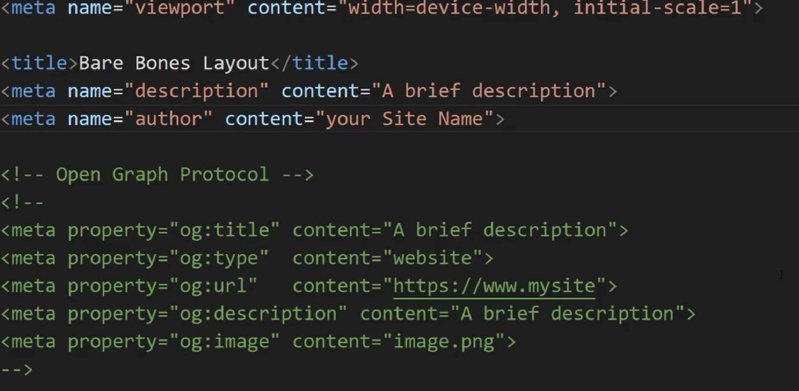  
  
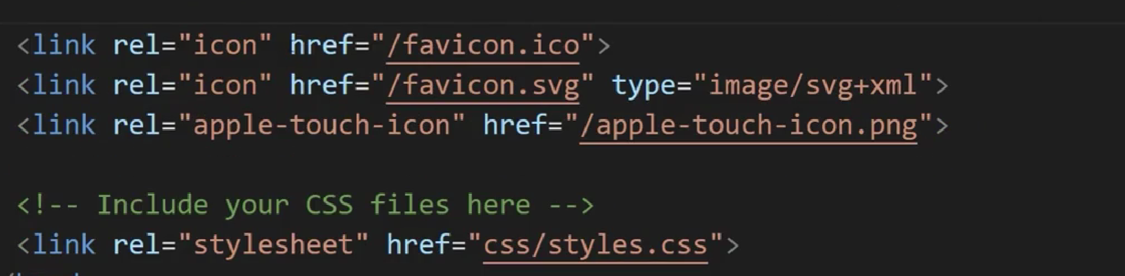  
**link the css in the last of the head element.  
below the fotter add the java script files.  
  
UX with meta tags**how social network produce a preview.  
how metatags creates preview of webpage.  
traditional SEO meta tags -> search results, not direct link.  
  
open graph protocol:  
**Frontend developers use the Open Graph Protocol to improve the user experience of shared links because it helps social media platforms create a preview of the shared web page.  
  
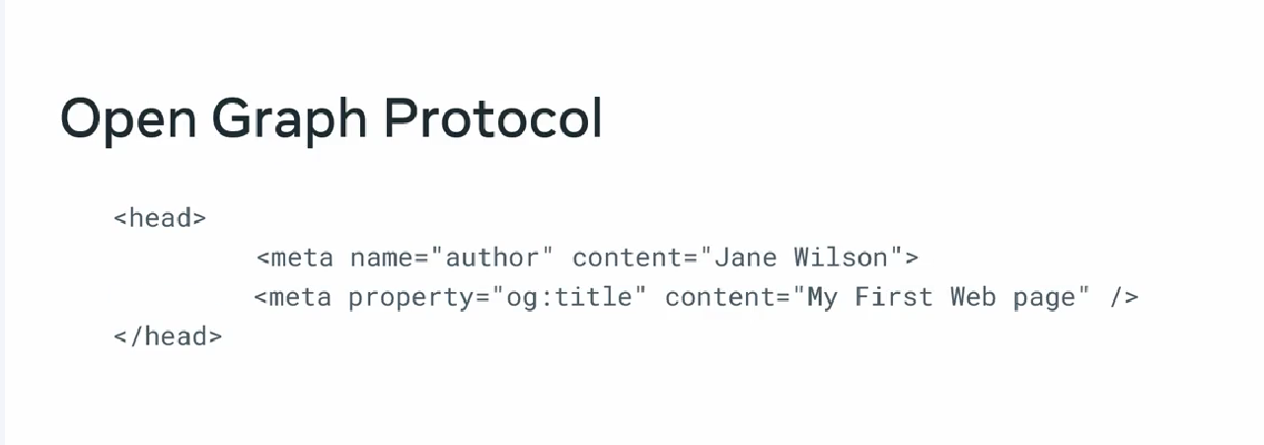  
need to add this 4  
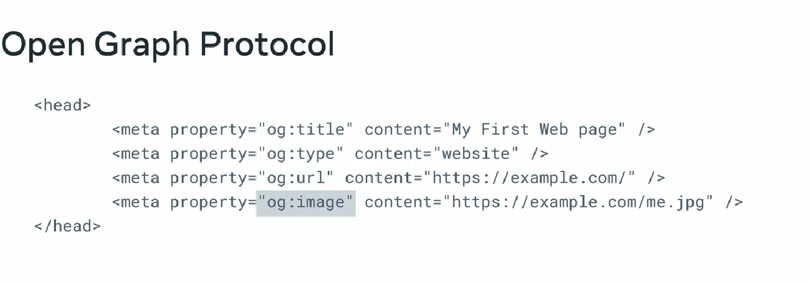  
description,locale,site_name  
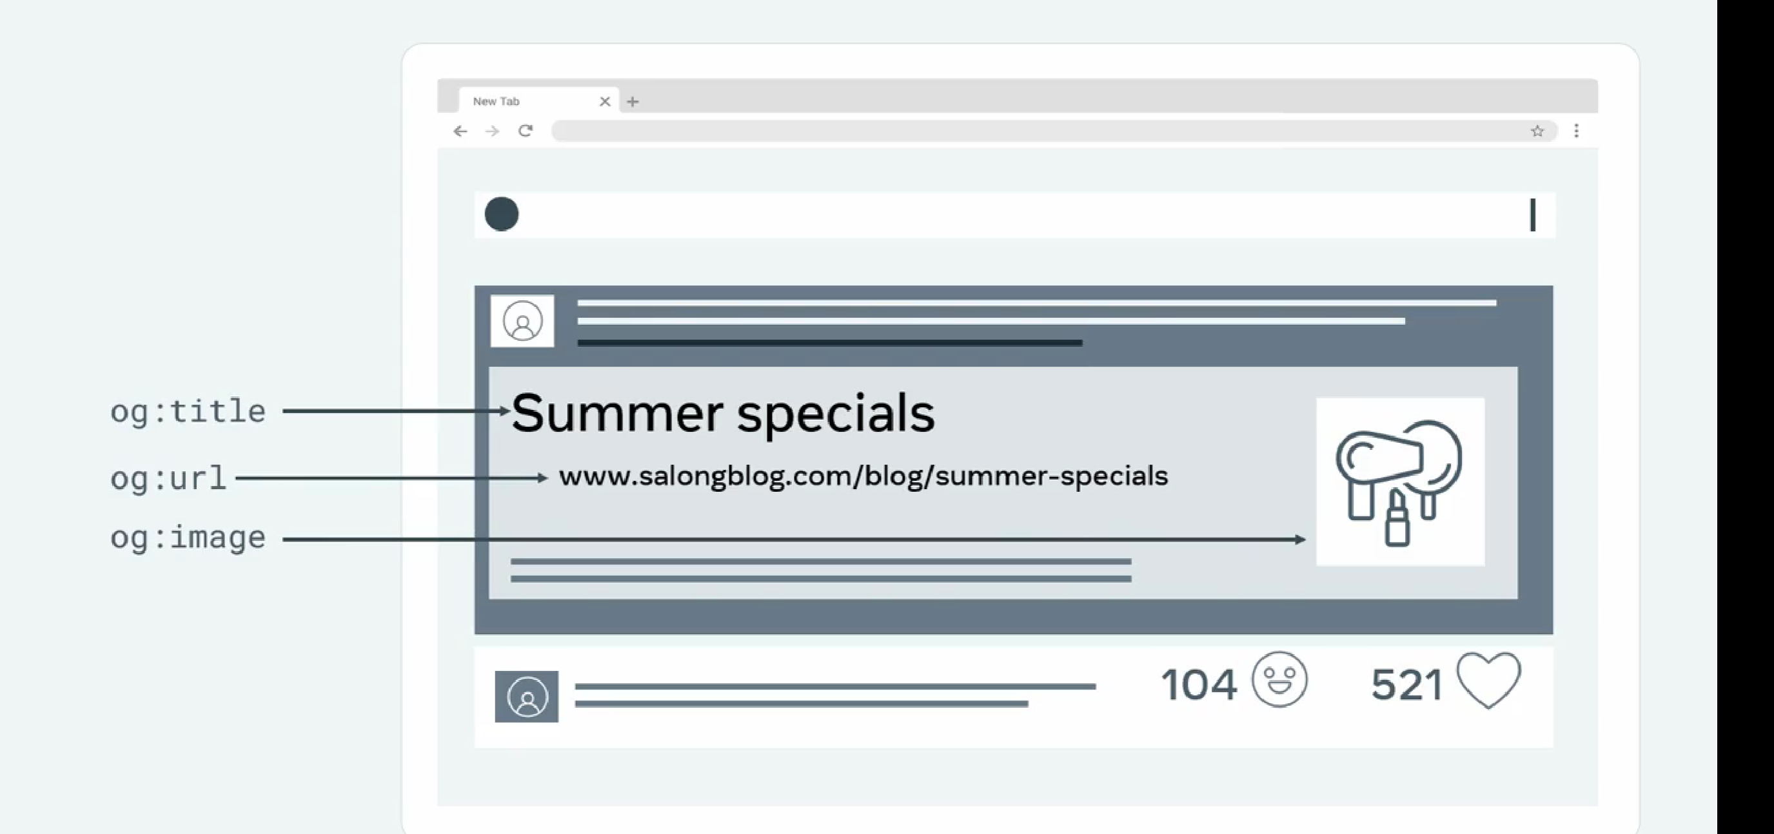  
  
setting up social media cards  
  
additional resources**  
https://developers.facebook.com/docs/sharing/webmasters/  
  
https://www.freecodecamp.org/news/what-is-open-graph-and-how-can-i-use-it-for-my-website/  
  
https://ogp.me/  
  
<https://developer.mozilla.org/en-US/docs/Web/HTML/Element/meta>  
  
https://css-tricks.com/essential-meta-tags-social-media/  
  
<https://www.digitalocean.com/community/tutorials/how-to-add-twitter-card-and-open-graph-social-metadata-to-your-webpage-with-html>  
  
https://www.vandelaydesign.com/newsletter-tutorial/  
  
https://www.instructables.com/Bare-Bones-Web-Page/  
  
https://www.freecodecamp.org/news/semantic-html5-elements/  
  
  
  
  
  
**22/08/23  
  
Forms and validation**  
data enter by the user is valid and conforms to defined rules  
  
**client side validation**  
checks by javascript as soon as they entered  
check the form Is correct or not  
**server side validation  
protect again suspicious entry**  
check after the data is submitted to server  
more complex checks  
  
for example:  
<input type=”email”>  
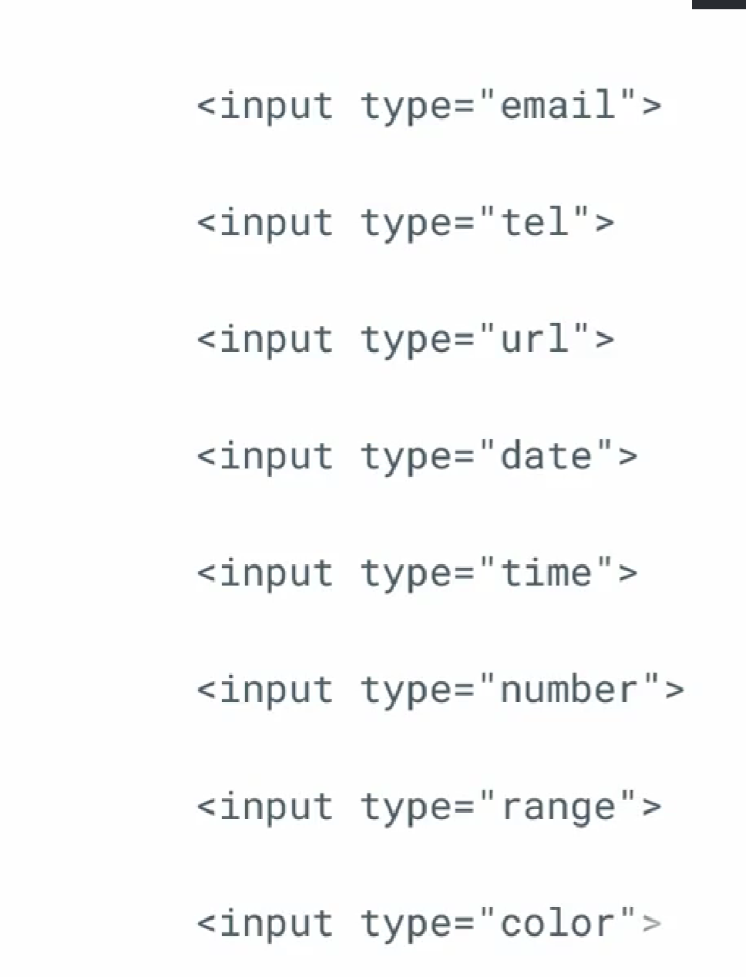

Required method

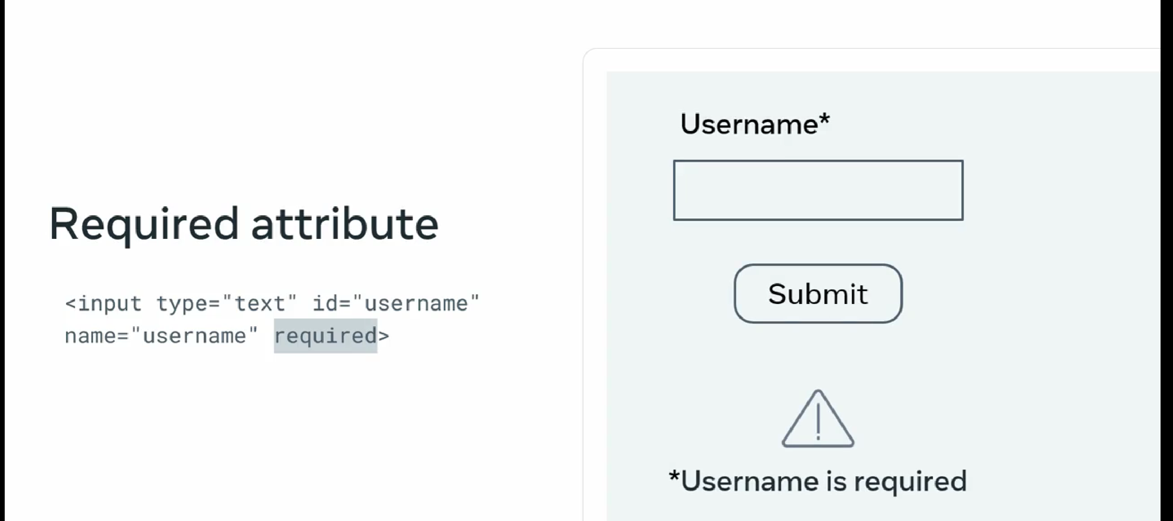  
  
**Button**

This displays a clickable button and it’s mostly used in HTML forms to activate a script when clicked. **<input type="button" value="Click me" onclick="msg()" />**

Keep in mind you can also define buttons with the **<button>** tag, with the added benefit of being able to place content like text or images inside the tag.

<button onclick="alert('Are you sure you want to continue?')">

    <img src="https://yourserver.com/button_img.jpg"

        alt="Submit the form" height="64" width="64">

 </button>

Check box:

<input type="checkbox" id="dog" name="dog" value="Dog">

<label for="dog">I like dogs</label>

<input type="checkbox" id="cat" name="cat" value="Cat">

<label for="cat">I like cats</label>

Radio:

<input type="radio" id="light" name="theme" value="Light">

<label for="light">Light</label>

<input type="radio" id="dark" name="theme" value="Dark">

<label for="dark">Dark</label>

Text:

<label for="fname">First name:</label>

<input type="text" id="fname" name="fname">

Password:

<label for="pwd">Password:</label>

<input type="password" id="pwd" name="pwd">

Date:

<label for="dob">Date of birth:</label>

<input type="date" id="dob" name="date of birth">

Datetime-local:

<label for="birthdaytime">Birthday (date and time):</label>

<input type="datetime-local" id="birthdaytime" name="birthdaytime">

Email:

<label for="email">Enter your email:</label>

<input type="email" id="email" name="email">

Files:

<label for="myfile">Select a file:</label>

<input type="file" id="myfile" name="myfile">

Hidden:

<input type="hidden" id="custId" name="custId" value="3487">

Image:

<input type="image"src="submit_img.png" alt="Submit" width="48" height="48">

Number:

<input type="number" id="quantity" name="quantity" min="1" max="5">

Range:

<label for="volume">Volume:</label>

<input type="range" id="volume" name="volume" min="0" max="10">

Reset:

<input type="reset">

Search:

<label for="gsearch">Search in Google:</label>

<input type="search" id="gsearch" name="gsearch">  
time:

<label for="appt">Select a time:</label>

<input type="time" id="appt" name="appt">  
  
tel:

<label for="phone">Enter your phone number:</label>

<input type="tel" id="phone" name="phone" pattern="[+]{1}[0-9]{11,14}">

url:

<label for="homepage">Add your homepage:</label>

<input type="url" id="homepage" name="homepage">

Month:

<label for="bdaymonth">Birthday (month and year):</label>

<input type="month" id="bdaymonth" name="bdaymonth" min="1930-01" value="2000-01">

**Making the most of clinet side validation  
  
no empty filed  
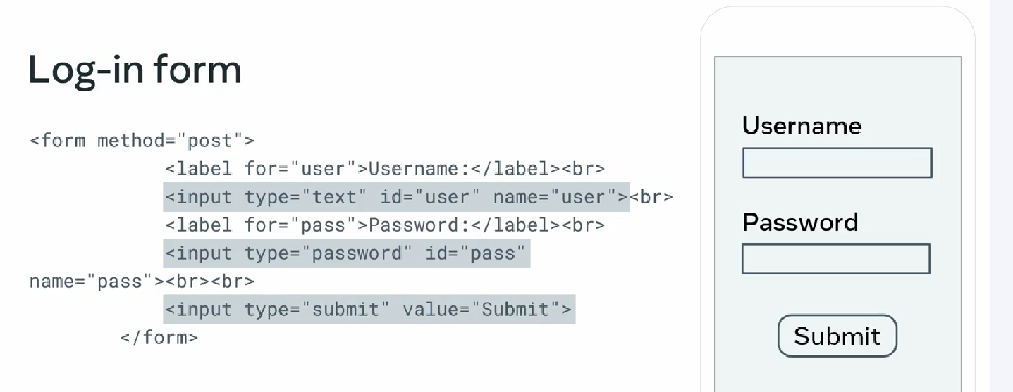**

Client side validation  
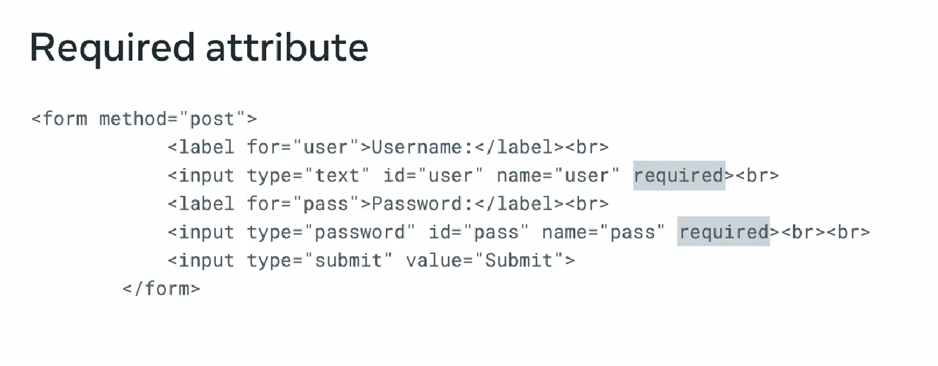  
 **length od input  
more then 3 max of 12**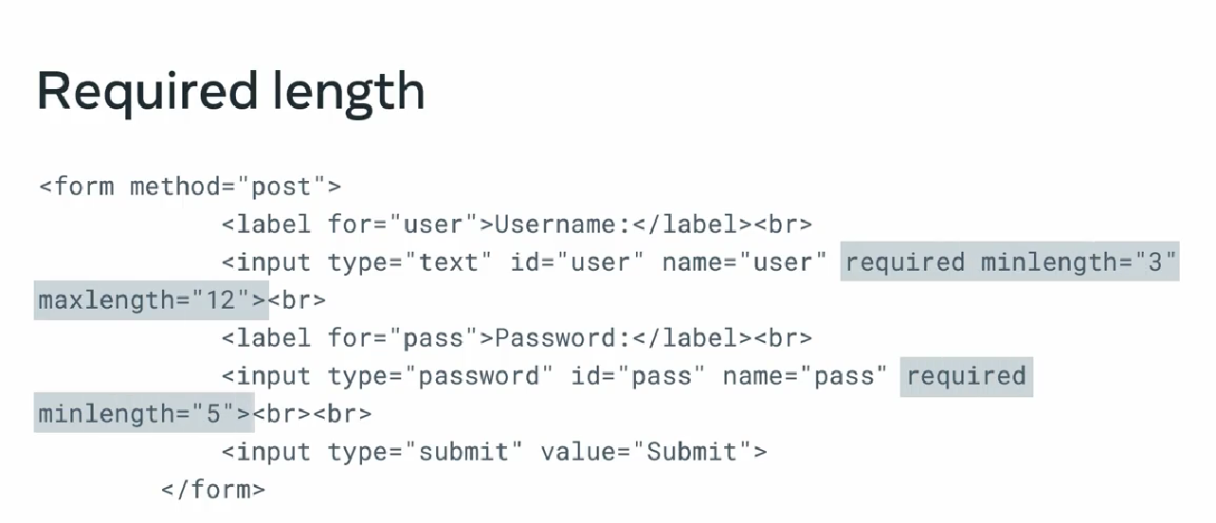

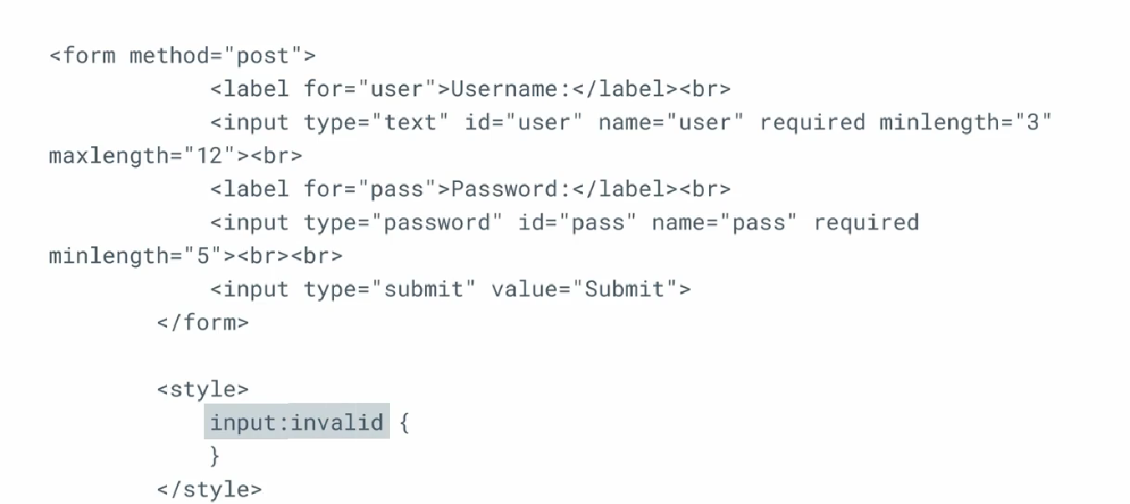

Use focus to only send invalid for wrong entry  
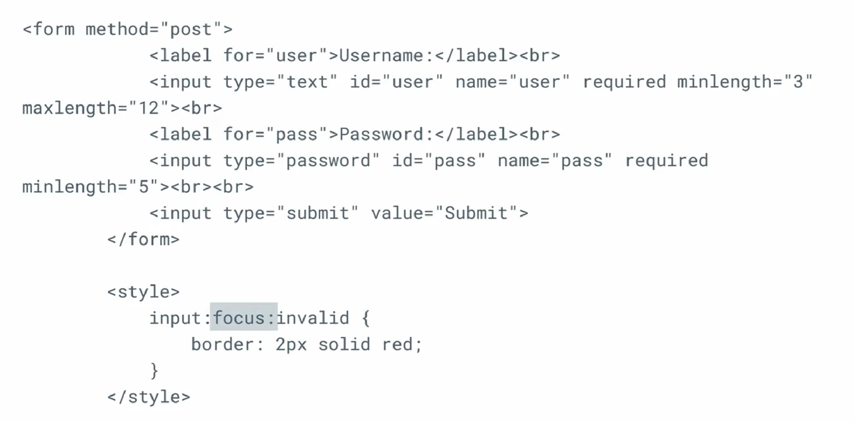

**Radio button  
  
23/03/25  
  
required:**

**<input type="text" id="firstName" name="firstName" required>  
max and min  
<input type="number" id="quantity" name="quantity" min="1" max="10">  
 <input type="range" id="volume" name="volume" min="1" max="100">  
  
multiple  
<input type="file" id="gallery" name="gallery" multiple>  
  
pattren  
<input type="tel" id="phone" name="phone" pattern=”^(?:0|\+?44)(?:\d\s?){9,10}$” >  
  
user interactive form elements  
 <label for="booking_people">Number of People</label>**

**<input type="range" id="booking_people" name="booking_people" min="1" max="10" value="4" oninput="*this*.nextElementSibling.value = *this*.value">**

**<!-- sematic html element that contin result of the calcluation -->**

**<output>4</output>**

simple javascript for scroll down when input changes

Datalist input type allow us to add more values later apper in drop down list  
  
<label for="booking_location">Location</label>

            <input id="booking_location" name="booking_location" list="location">

            <datalist id="location">

                <option value="Down town"></option>

                <option value="Up down"></option>

            </datalist>

**form submisson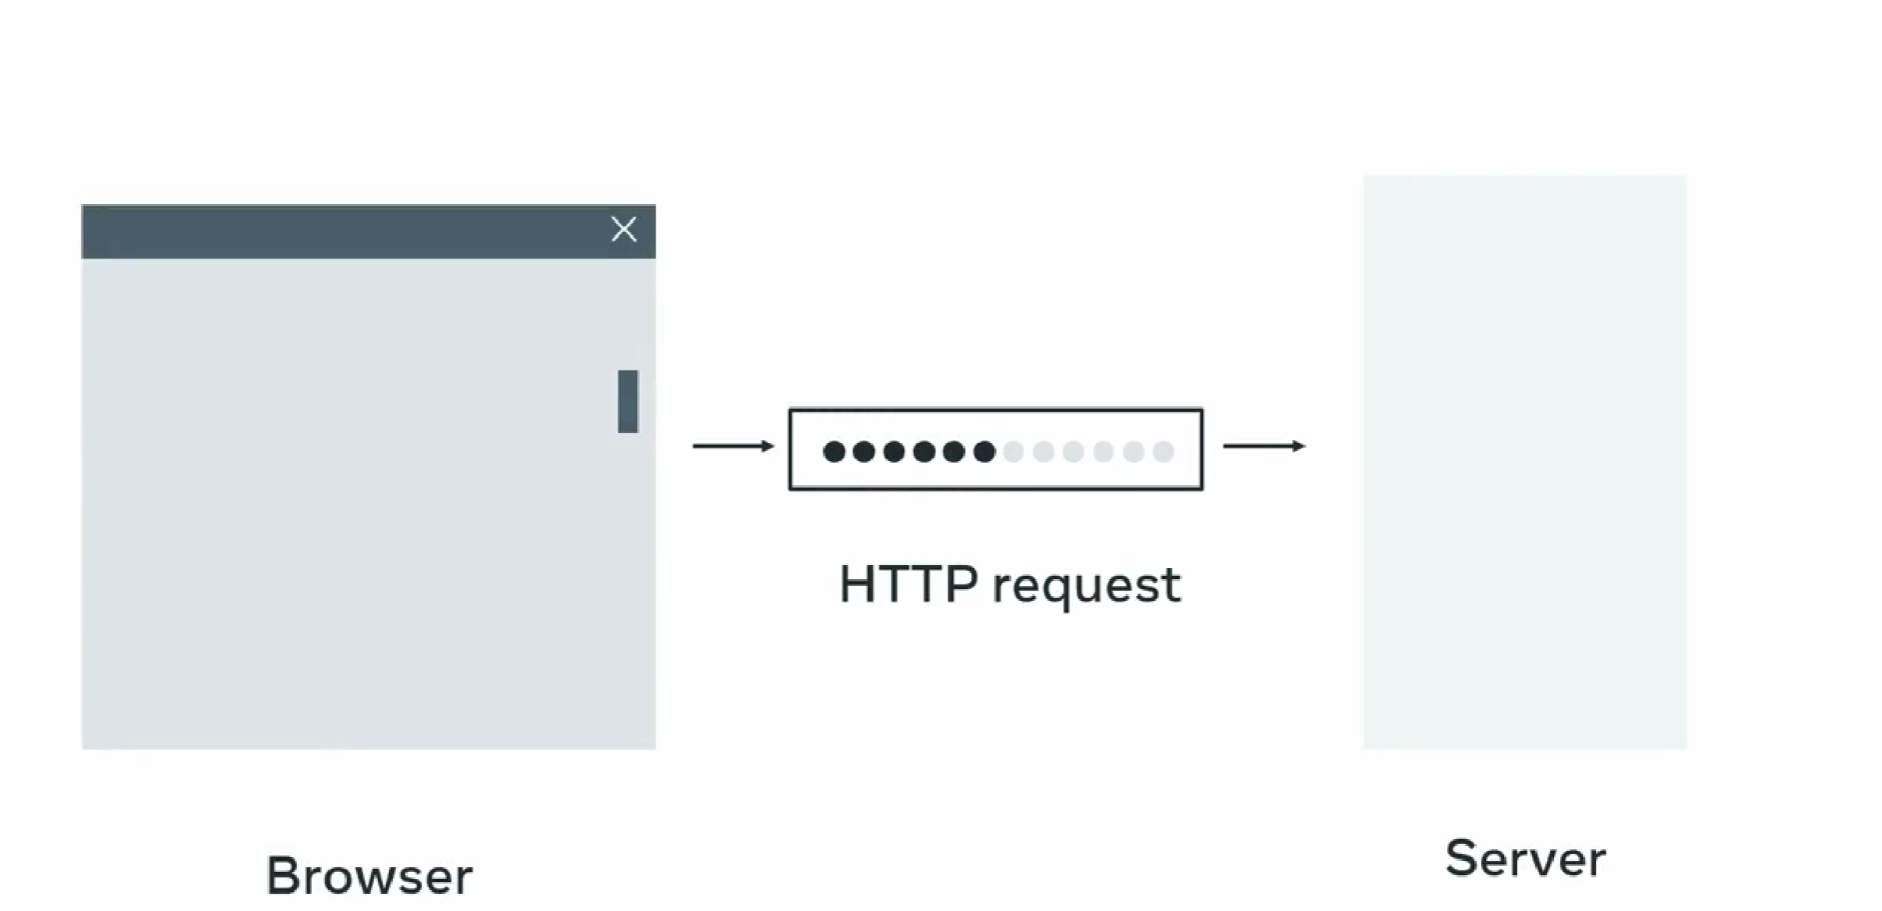 two method form can send data to the server  
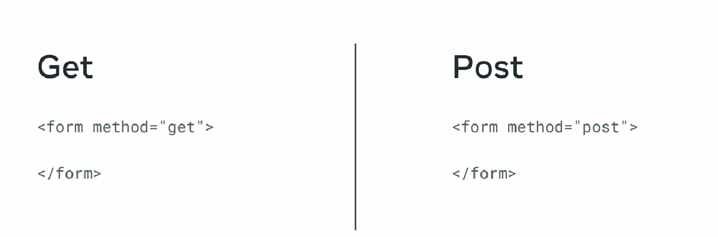  
get ()  
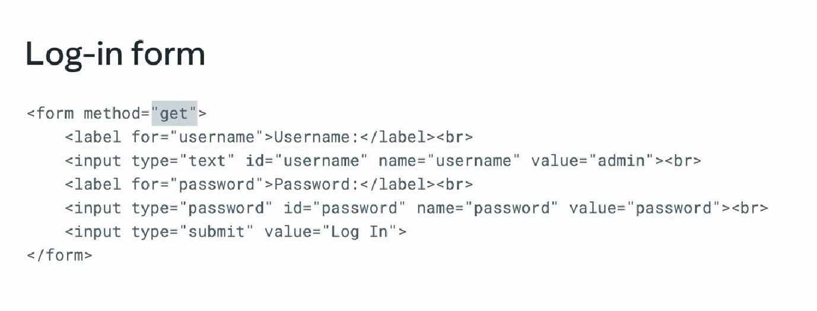  
  
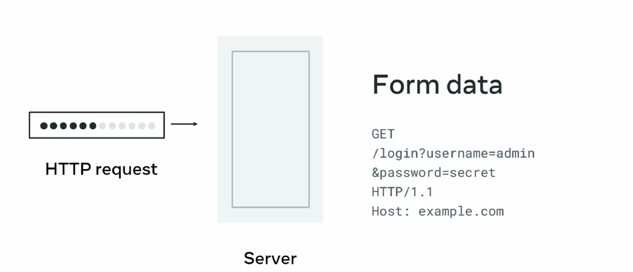  
  
cons  
URL length limit by browser, by web server, security threats**

**post()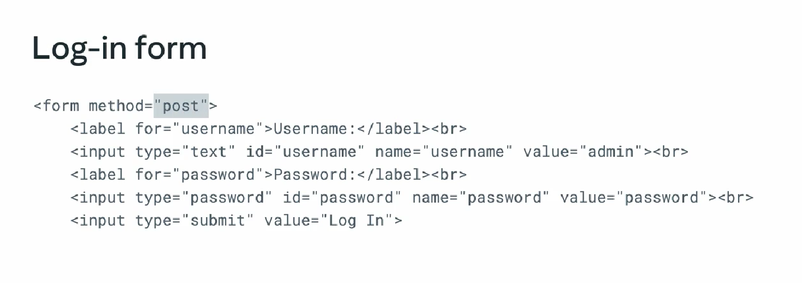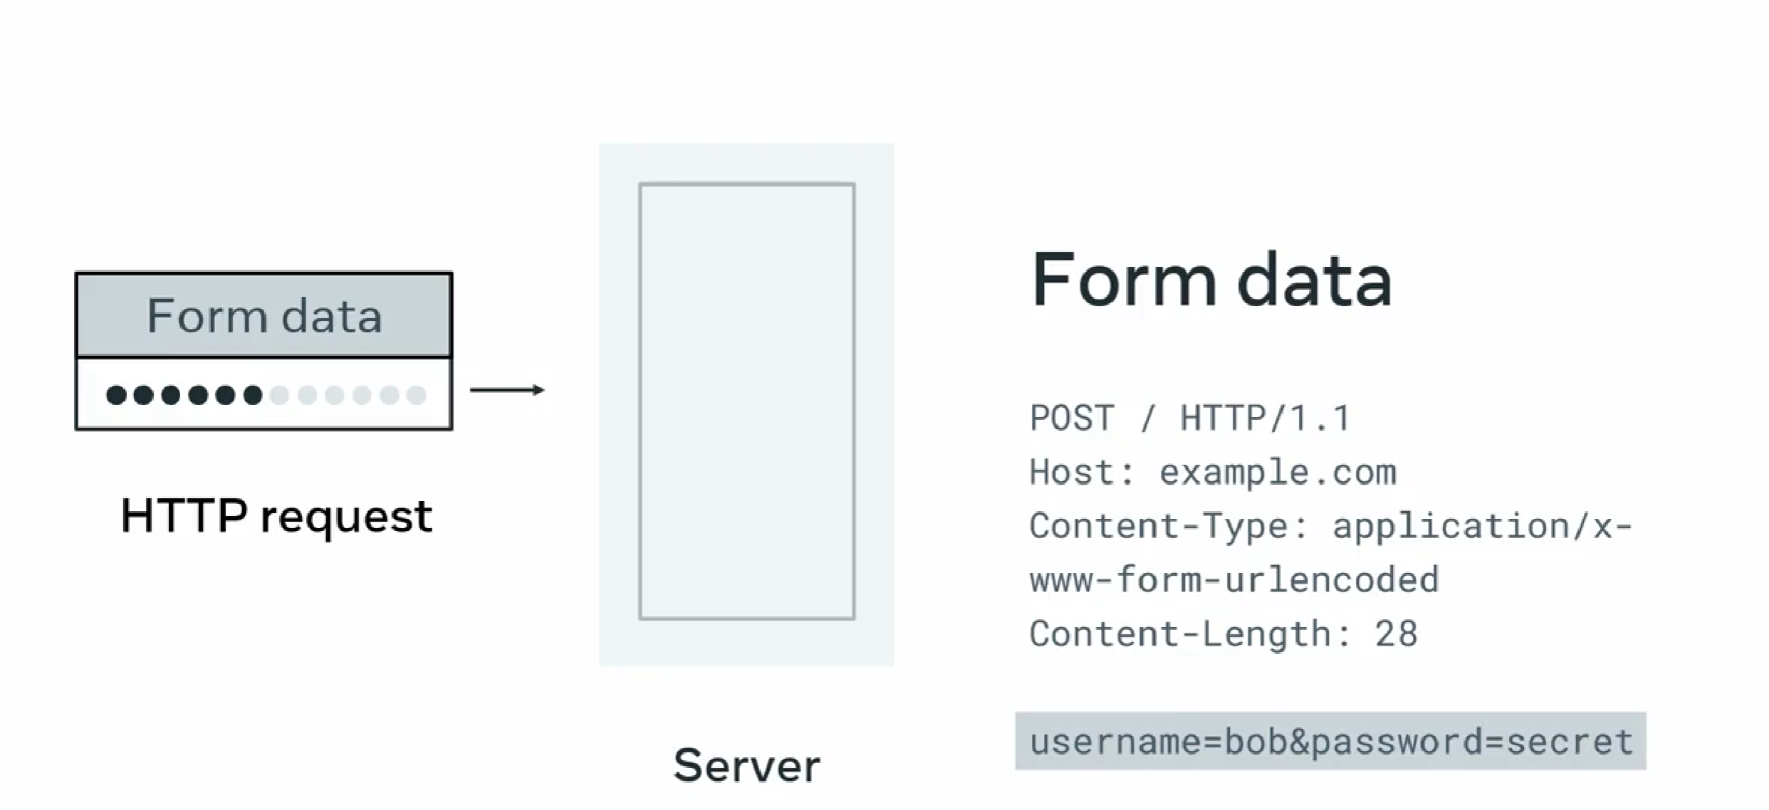 more secure then get()  
but secure completely,  
HTTPS Is used to encrypte the data**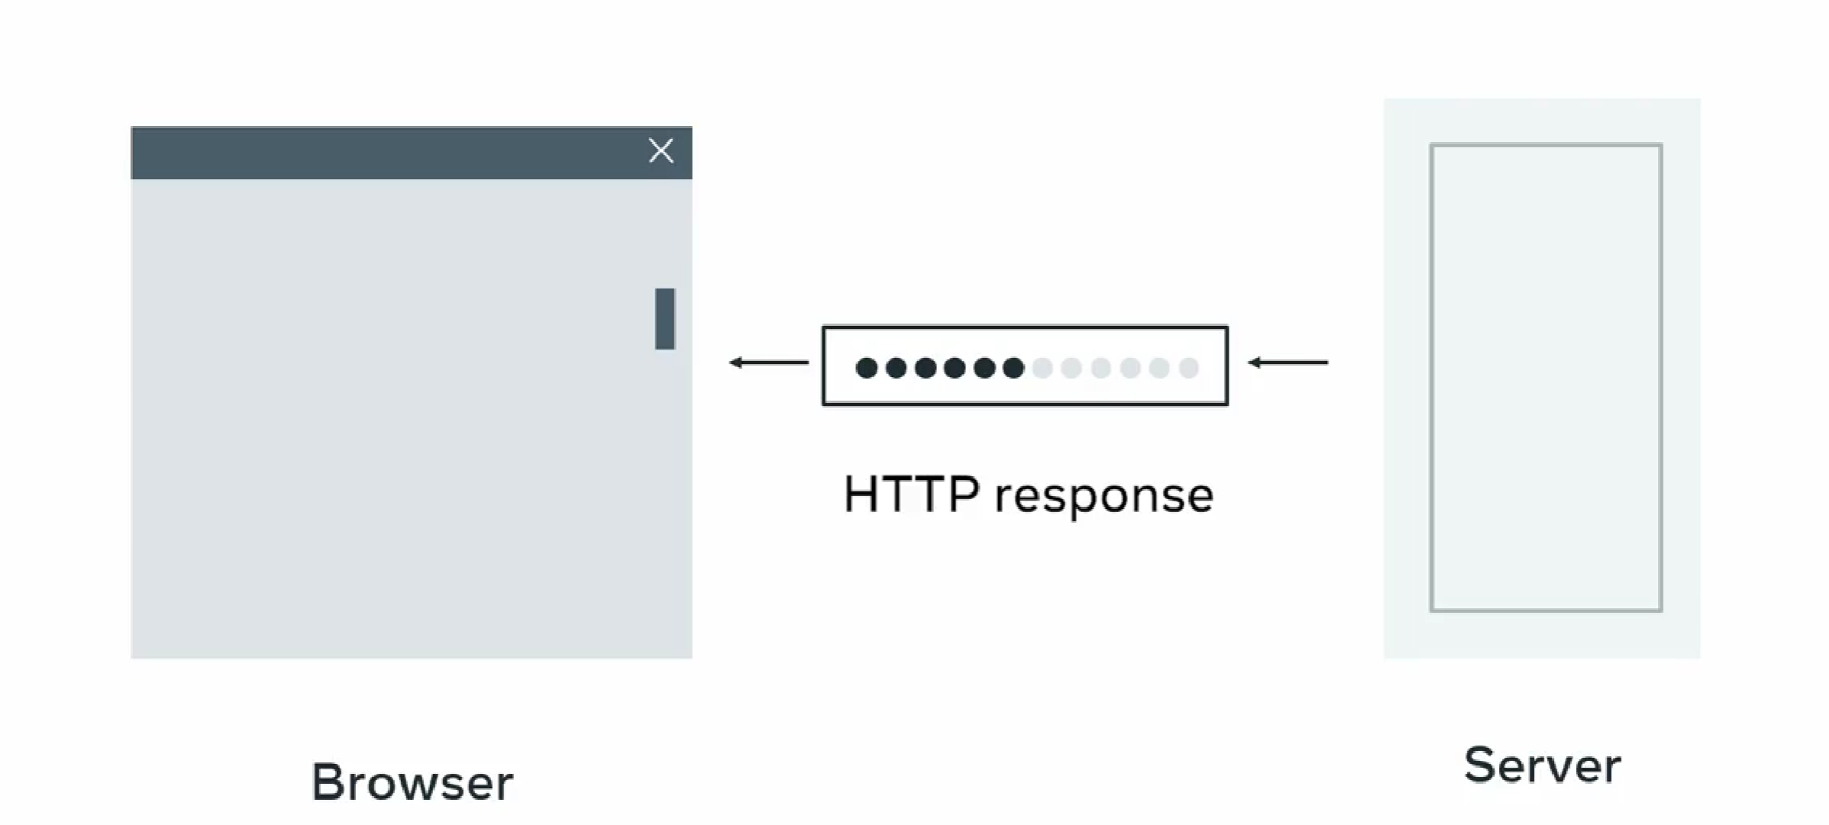The action attribute specifies to which web address the form must be sent. This is address is location of server-side code that will process the request.  
  
<form action="/login">

</form>

action can be a full URL address such as **https://meta.com**, an absolute path such as **/login**, or a relative path such as **login**.  
  
Similarly, a relative path will combine the current web address with a relative path. For example, if the web browser is currently on the web page **https://meta.com/company-info/**, and the relative path is set to **login**, the form will be submitted to **https://meta.com/company-info/login**.  
  
when the form is submitted using the **HTTP GET method, the data in the form's fields are encoded in the URL**. And **when the form is submitted using the HTTP POST method, the data is sent as part of the HTTP request body**.  
  
browser difference:

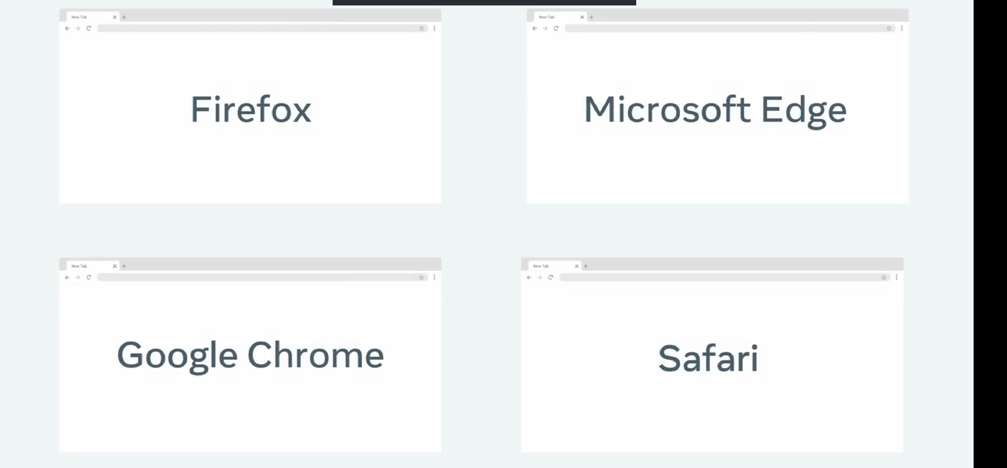  
  
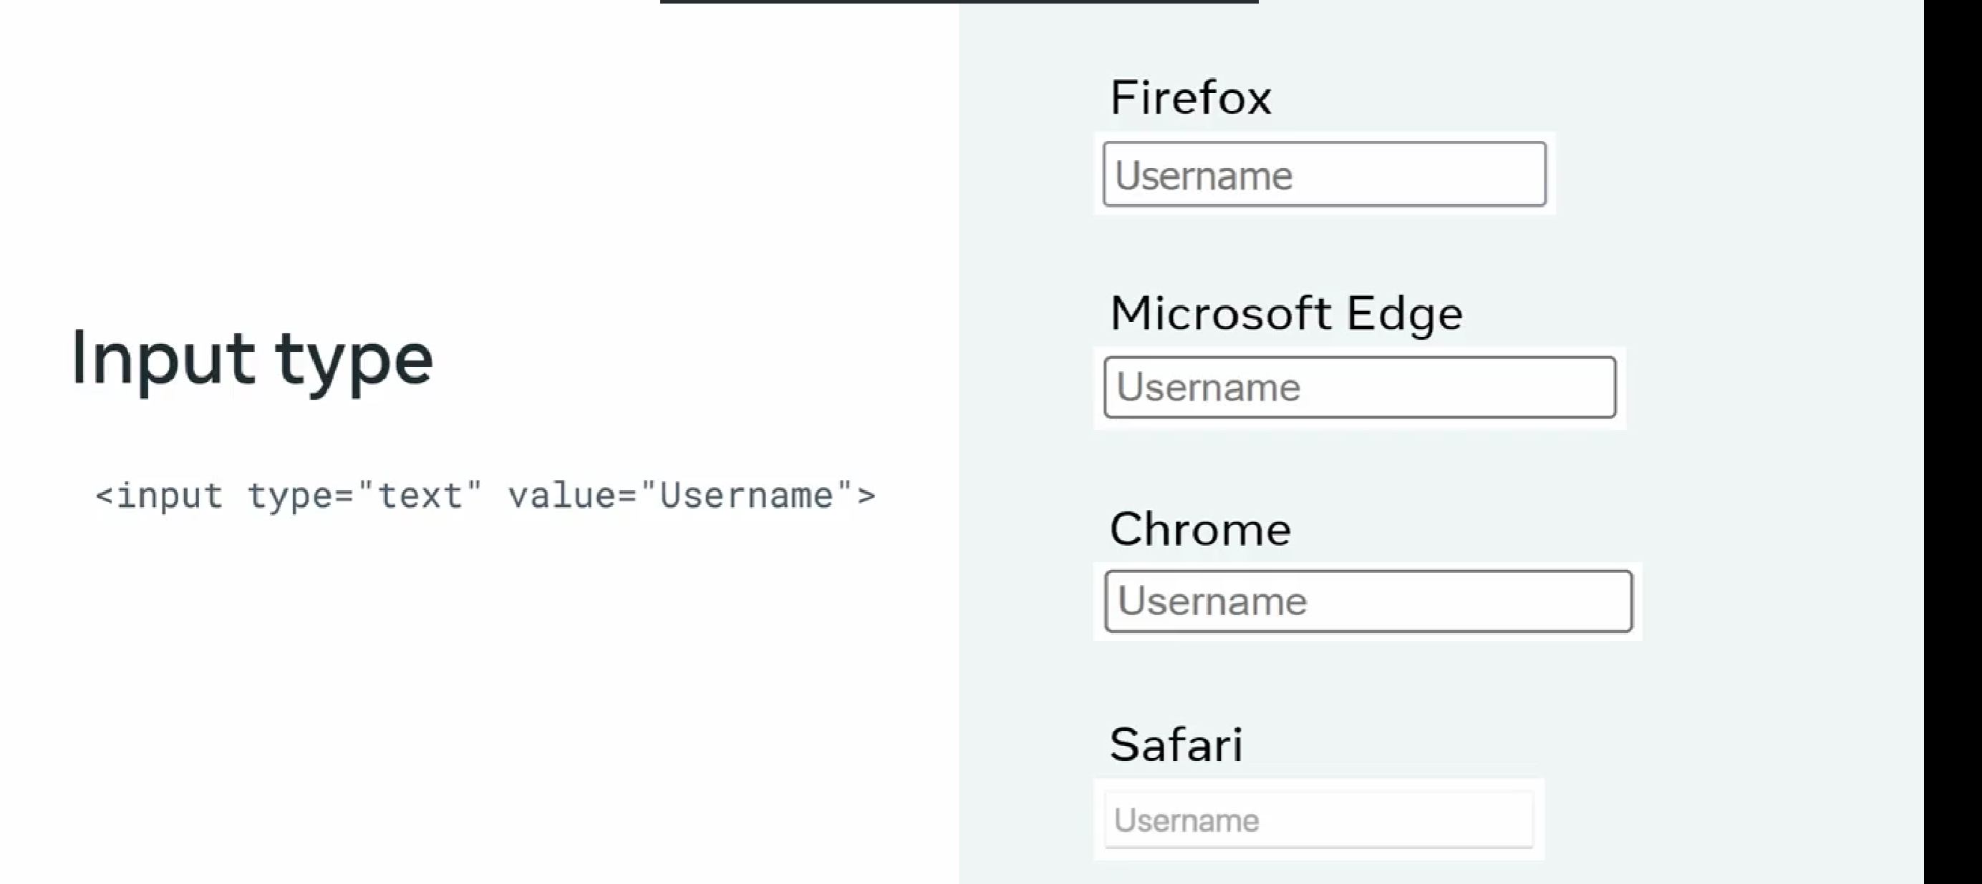  
  
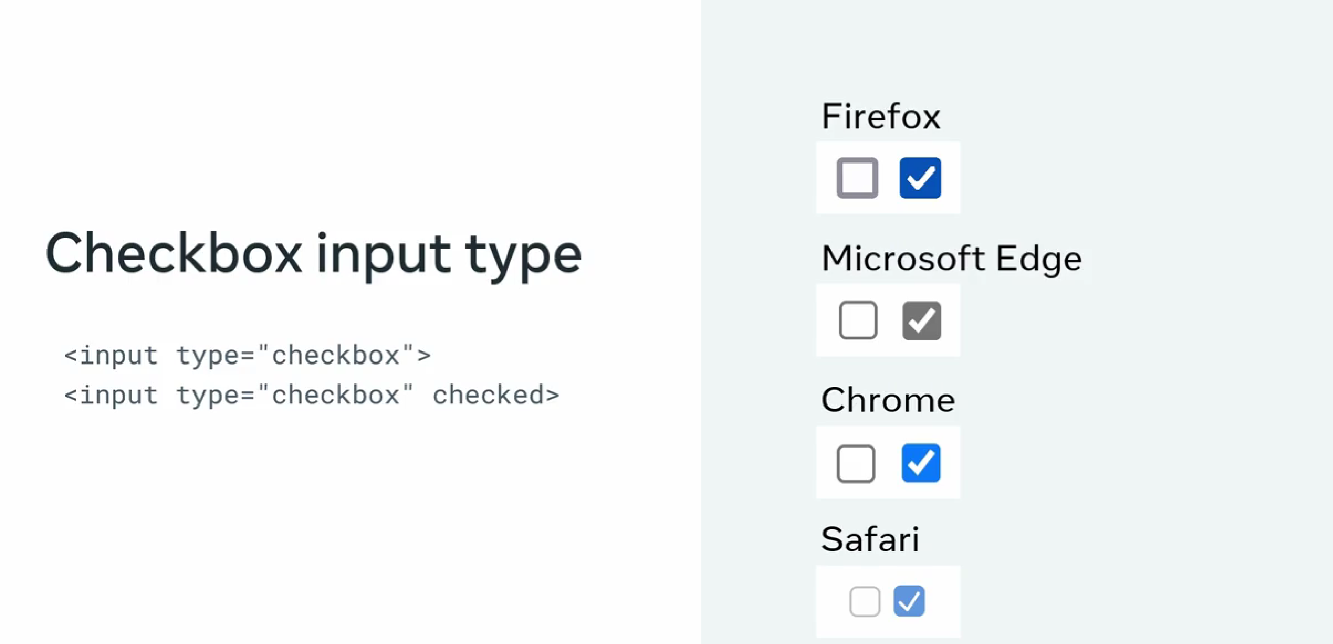  
how to solve this?  
use css rules  
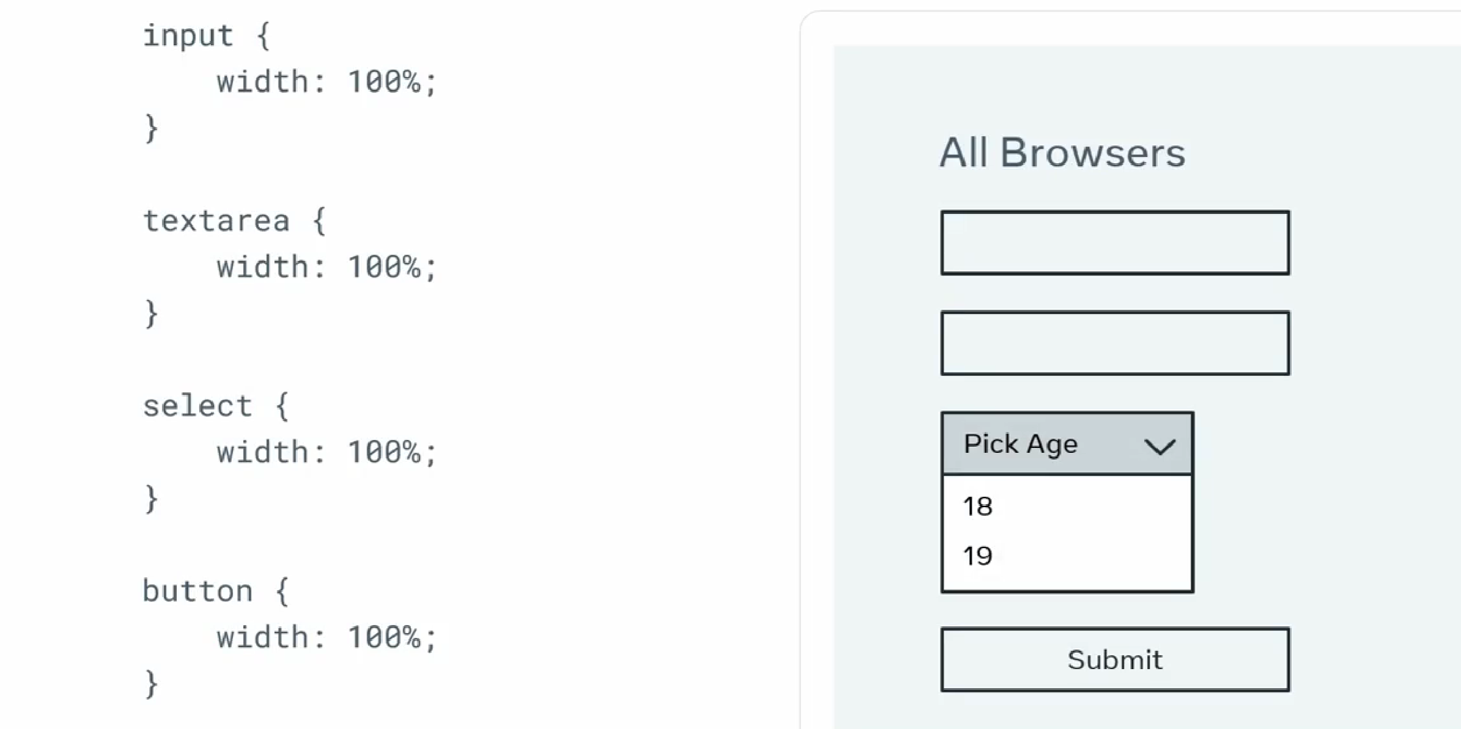  
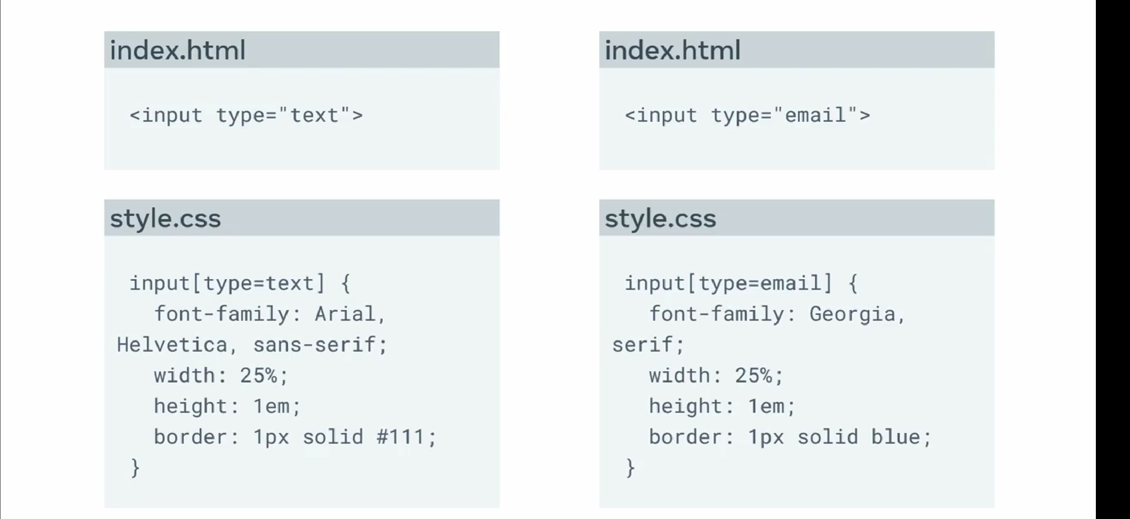  
**framework library  
Bootstrap, Tailwind CSS, foundation  
  
buttons:**<button type="button" onclick="alert('You just clicked!')">Click Me!

</button>

Legends  
<fieldset>

  <legend>Personal Info</legend>

  <label for="fname">First name:</label><br>

  <input type="text" id="fname" name="fname" value="John"><br>

  <label for="lname">Last name:</label><br>

  <input type="text" id="lname" name="lname" value="Doe"><br>

</fieldset>

<fieldset>

  <legend>Qualificaiton</legend>

  <label for="pdegree">Primary degree:</label><br>

  <input type="text" id="pdegree" name="degree" value="Masters"><br>

  <label for="fos">Last name:</label><br>

  <input type="text" id="fos" name="field" value="Psychology"><br>

</fieldset>

To infrom user its wrong:  
  
input:focus:invalid {

    color: red;

    border: red 3px solid;

}

Additional Source  
  
<https://developer.mozilla.org/en-US/docs/Learn/Forms/Sending_and_retrieving_form_data>  
  
https://www.webfx.com/web-design/learn/why-does-your-website-look-different-in-different-browsers/  
  
<https://developer.mozilla.org/en-US/docs/Web/HTML/Element/input/radio>  
  
https://www.the-art-of-web.com/html/html5-form-validation/  
  
<https://developer.mozilla.org/en-US/docs/Web/HTML/Element/input>  
  
https://www.sitepoint.com/client-side-form-validation-html5/  
  
video audio  
  
video and audio tags  
for videos .mp4, .webm, .ogg  
for audio .mp3, .wav, .ogg  
  
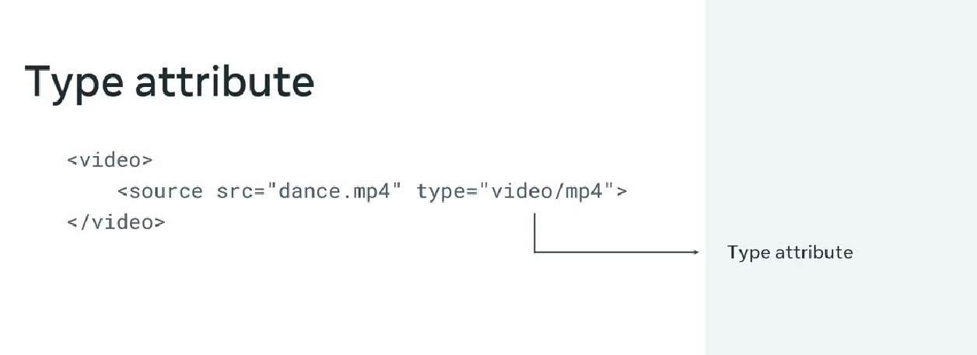  
  
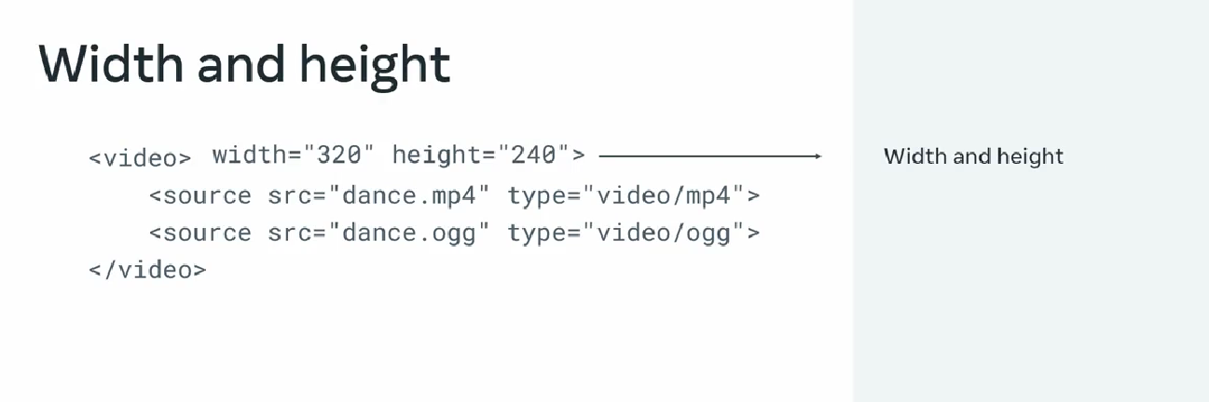  
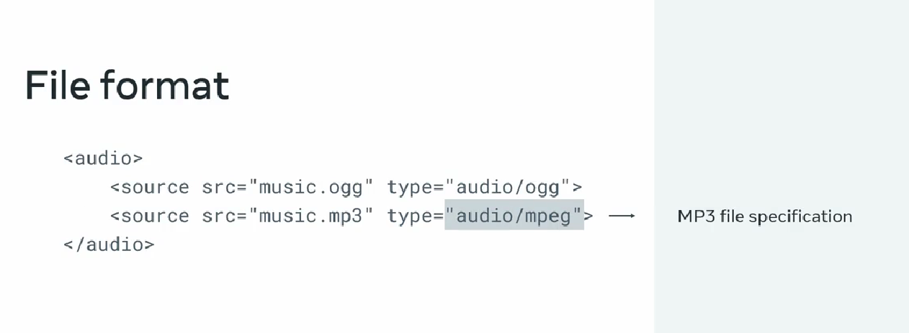  
  
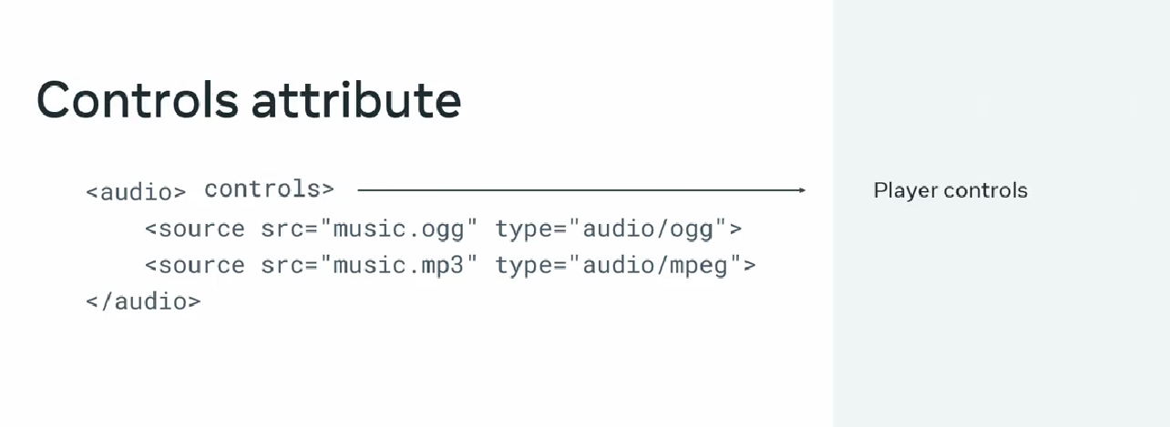  
embedded players  
  
images:

It is important to ensure that screen reader accessibility software can interpret images displayed in the web browser. To support this, the <img> tag is combined with the **<figure>** and **<figcaption>** tags to provide a description of the image. The **<img>** tag is added inside the **<figure>** tag and the **<figcaption>** is specified after it.  
  
<figure>

   <img src="photo.png" width="320" alt="My Profile Photo">

   <figcaption>A photo of myself on a beach in 2015</figcaption>

</figure>

Iframes:  
  
The **<iframe>** is the inline frame element that embeds an HTML page into another page. Apart from the global attributes, which can be a part of the **iframe**, major element-specific attributes are listed below.

**allow**

It specifies what features or permissions are available to the frame, for instance, access to the microphone, camera, other APIs and so on. For example:

* **allow="fullscreen”** the fullscreen mode can be activated
* **allow=“geolocation”** lets you access the user’s location

To specify more than one feature, a semicolon-separator should be used between features. For example, the following would allow using the camera and the microphone:

**<iframe src="https://example.com/…" allow="camera; microphone"> </iframe>**

**name**

The name for the **<iframe>**. For example: **<iframe name = "My Frame" width="400" height="300"></iframe>**

**height**

It specifies the height of the frame. The default value is 150, in terms of CSS pixels. width

**width**

Specifies the width of the frame, in terms of CSS pixels. The default value is 300 pixels.

**referrerpolicy**

A referrer is the HTTP header that lets the page know who is loading it. This attribute indicates which referrer information to send when loading the frame resource. The common values are:

* **no-referrer** The referrer header will not be sent.
* **origin** The referrer will be limited to the origin of the referring page
* **strict-origin** The origin of the document is sent as the referrer only when using the same protocol security level (HTTPS to HTTPS)

An iframe is HTML element that allows you to place or embed content from another website into webpage.  
  
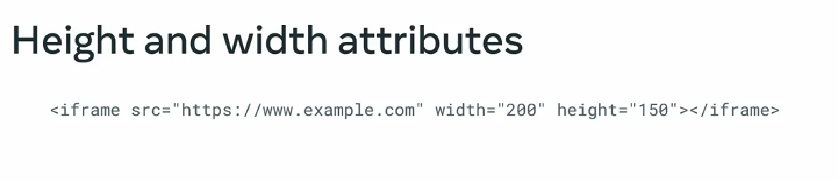  
allow attribute  
 no camer,microphone.  
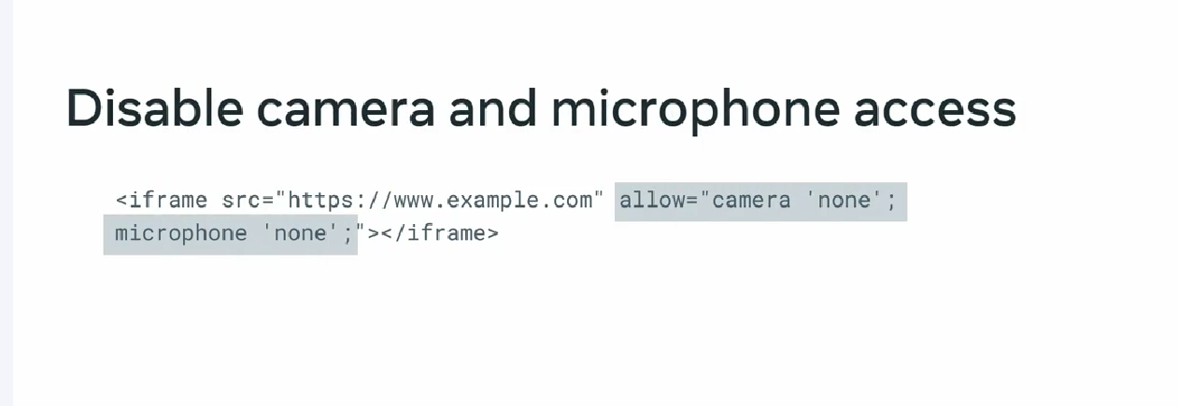  
sandbox attribute  
  
**sandbox**

To enforce greater security, a sandbox applies extra restrictions to the content in the **<iframe>**. To lift particular restrictions, an attribute value (permission token) is used. The common permission tokens are listed below:

* **allow-downloads** Allows the user to download an item
* **allow-forms** Allows the user to submit forms
* **allow-modals** The resource can open modal windows
* **allow-orientation-lock** Lets the resource lock the screen orientation
* **allow-popups** Allows popups to open
* **allow-presentation** Allows a presentation session to start
* **allow-scripts** Lets the resource run scripts without creating popup windows

no downloads, popups  
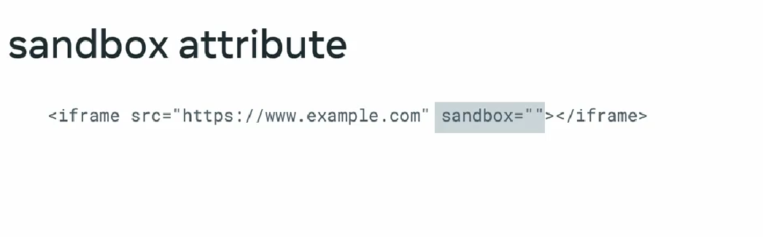  
sandbox=”” means all the restriction are applied  
  
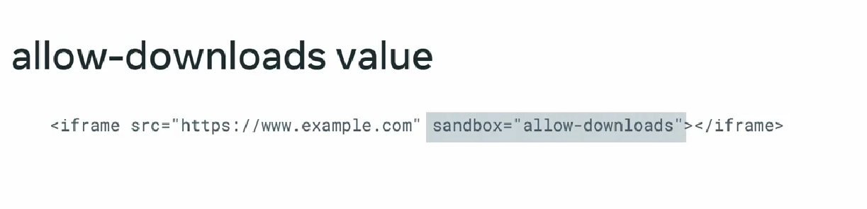  
  
**loading**iframe should be loaded immediately when the web page loads (**eager**) or loaded when iframe is displayed in the browser (**lazy**).

<iframe src="my_iframe_src.html" loading="lazy" >

</iframe>   
  
**srcdoc**

Let's you specify the inline HTML to embed in the **<iframe>**. When defined, this attribute would override the **src** attribute.

<iframe src="my_iframe_src.html" srcdoc="<p>My inline html</p>" >

</iframe>

**title**

<iframe src="history.html" title="An embedded document about the history of my family" >

</iframe>  
  
iframes as a picture:

**Media elements**  
Canvas elements:  
  
**GIF** gif interchange format along with **webP** used for animation images.

Using this zero interactivity but embed animated content.

**2D Canvas**  
  
2d graphics drawn on webpages, 2d games, animation  
  
**webGL**  
for 2d and 3d graphics and advance graphics  
GPU is used to rendering  
  
explore canvas elements  
  
additional resources:

<https://html.spec.whatwg.org/multipage/media.html>  
  
<https://www.tutorialrepublic.com/html-tutorial/html5-canvas.php>  
  
https://www.educba.com/iframes-in-html/  
  
<https://developer.mozilla.org/en-US/docs/Learn/HTML/Multimedia_and_embedding/Images_in_HTML>  
  
<https://studio.support.brightcove.com/publish/choosing-correct-embed-code.html>  
  
https://html.com/media/